# WAOL v2.0 Tip sheet

Tip sheet for using the new version of the Western Australian Organism List released November 2015.

*Please note, the content shown in the application screenshots are of a general nature and should not be considered official legal information.*

## Purpose

The new version of WAOL has been built to make it easier for you to search, refine and export organism declaration and taxonomic information across over 50,000 organisms. It is also optimised for mobile devices as well as desktop, and uses modern mapping features to depict control categories across the state.

## Usage

There are two main ways to use the new version of WAOL, searching by string or by a pre-filter.

### Search by string

Enter an organism’s scientific name, common name, phylum, class, order or family into the search box and click search. You can enter parts of words or full names if you know them:

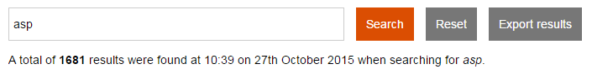

Once you’ve clicked search, you can either browse through the list (20, 50, 100, 200 items at a time) or use the refine results tools to limit the search results by Legal status and other filters (see below):

screen shot of results list


### Search by pre-filter

If you aren’t sure on the exact name of the organism or you want to see complete lists of certain types of organisms, you can use one of the pre-filters from the launch page. These pre-filters can start from a Legal status, control category, keeping category, scientific classification, ranking, presence in state, or local government area:

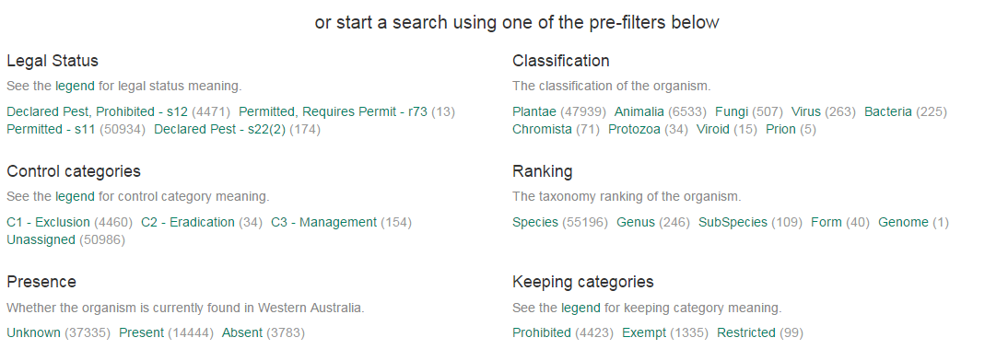

Like the first method, once you follow one of these pre-filter links you can see all organisms of this type:

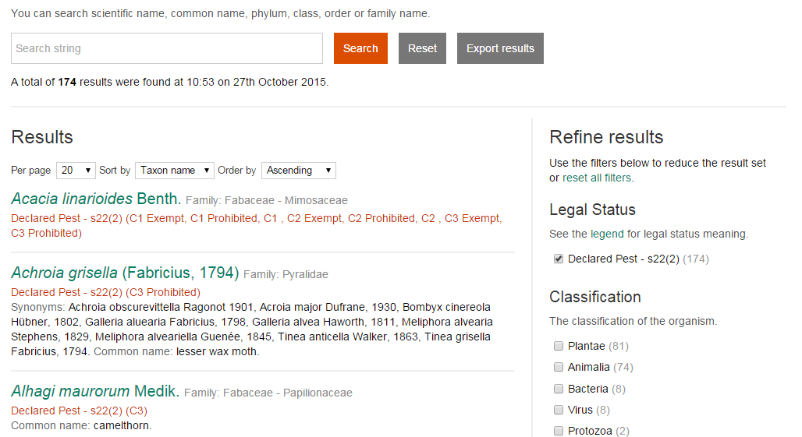

### Exporting lists

As you may notice, exporting lists of organisms is possible on any search by string or pre-filter simply by clicking on the “Export results” button at the top:

screen shot of export lists tab


Upon clicking “Export results” you will be asked to select a download format.

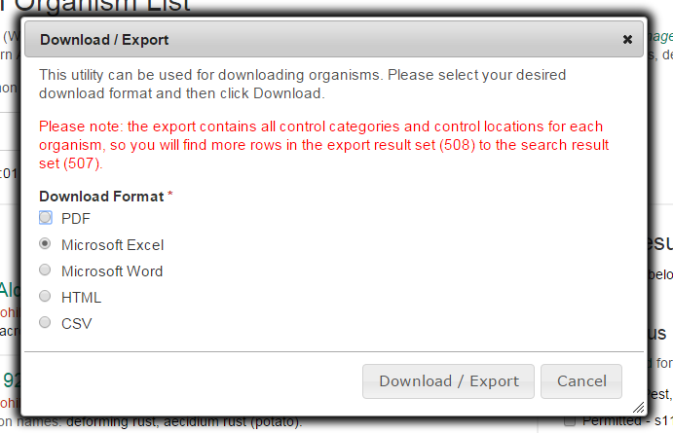

Note: the export functionality can take up to 60 seconds to complete when exporting greater than 4000 organisms.

### Viewing an organism

You can view an organism’s detailed information, simply by clicking on the organism name from the search results. The organism view shows synonyms, common names, legal status, control and keeping categories by list or map, scientific classification, authors, and links to other articles and resources regarding the organism.

screen shot of organsim page without map
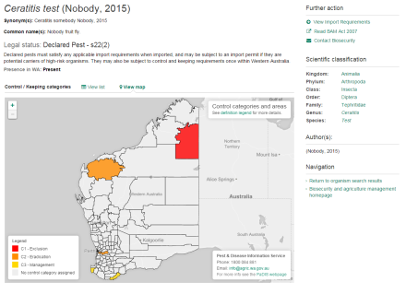

### Searching by local government area

**Please note:** ‘Whole of State’ search results only show organisms that are declared for every LGA (i.e. Declared at the ‘Whole of State’ level). Search results do not include organisms which are declared for a portion of the State or are declared under different control categories within the State. Search results for individual or multiple LGAs will include all organisms declared at the ‘Whole of State’ level.

If you have any feedback on the new WAOL, please contact us on [info@agric.wa.gov.au](mailto:info@agric.wa.gov.au).

### Important disclaimer

The Chief Executive Officer of the Department of Agriculture and Food and the State of Western Australia accept no liability whatsoever by reason of negligence or otherwise arising from the use or release of this information or any part of it.

Copyright © Western Australian Agriculture Authority, 2015