Department of Agriculture and Fppd Logo

# The Western Australian Sheep Industry

Western Australia (WA) produces some of the finest lamb, mutton and wool in the world and exports to over 100 countries. Sheep are produced in the south west of the State on broadacre farms, with world class welfare, food safety and environmentally responsible systems. Farms are mostly family owned enterprises where sheep are grazed under extensive conditions on pastures grown in rotation with crops for grain production. Most sheep meat products are exported along with the considerable amount of Merino wool produced in the State.

Australia is the world’s largest exporter of livestock, and is the sole supplier of livestock to some overseas markets. Approximately 28% of Western Australian sheep meat was exported as live sheep in 2015/16.

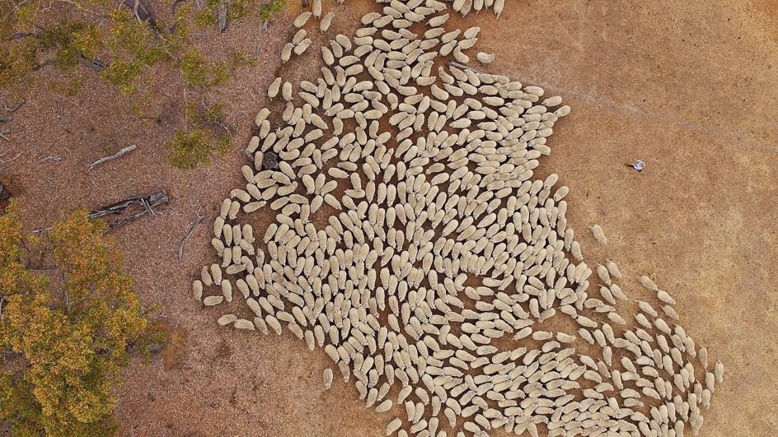

“There were approximately 5250 sheep farm businesses in WA in 2015, with an average flock size of 2700 sheep.”

**Supporting your success**

## The sheep production system

Sheep production occurs mainly in the agricultural zone in the south west of Western Australia. This region has a Mediterranean type climate with cool wet winters and hot dry summers such that pasture grows between May and October. Rainfall ranges from 300-700 mm per year (Figure 1) with less being received in the eastern and northern regions that are furthest from the coast.

Sheep flocks are generally run in conjunction with other enterprises, predominantly grain production, on mixed enterprise farms. The sheep enterprise utilises approximately 30-40% of the arable area on the average farm. Lambs are produced for slaughter throughout the year. During the growing season sheep graze green pasture consisting of annual grasses and legumes. During summer and autumn the pastures senesce and dry out but crop residues (stubbles) become available for grazing. Both stubbles and dry pasture can then be grazed, and are supplemented with cereal grains (e.g. oats and barley) and legumes (lupins) to satisfy the animals’ energy and protein requirements. Perennial pastures are grown in coastal areas and provide green feed for most of the year on these farms. Relatively small numbers of sheep are run in the rangeland districts in the Gascoyne and Goldfields districts.

Western Australian sheep are predominantly Merino, a wool breed, such that 84% of the total number of ewes in WA (6.3 million) are Merino. The remaining 1.2 million ewes consist of British breed Merino crossbreds, dual purpose and specialist meat breeds. This combination enables the industry to produce both meat from lambs and high quality wool from adult animals.

## The WA sheep flock

The WA sheep flock was estimated to be 14 million sheep and lambs in July 2015. This included 7.5 million breeding ewes, of which 6.7 million were mated.

There were approximately 5250 sheep farm businesses in WA in 2015 with an average flock size of 2700 sheep. Flock size varies in WA, however according to the 2011 census 17% of sheep farms had flocks containing over 4000 sheep and accounted for 50% of Western Australian ewes.

The WA sheep flock has restructured over the last 30 years with the breeding ewe proportion of the flock increasing (from 45 to 61%) and the proportion of wethers decreasing (down to 9% from 32%). This is predominantly in response to the increased importance of meat production to the sheep enterprise and a reduced reliance on wool production.

Sheep in WA constitute 20% of the national flock. Gross value of agricultural production (GVAP) of the WA sheep industry was $478.9 million for sheep and lamb disposals (slaughter and live export) and $540.5 million for wool at the close of 2014/15.

Total sheep turnoff (sheep meat and live export) during 2015/16 reached 5.86 million head. This was composed of 1.36 million sheep and 2.75 million lambs going through processing plants, 1.67 million sheep exported live and 83 800 transferred interstate.

Abattoirs and saleyards are regionally based close to sheep populations whilst the live export port is centrally located in Fremantle (Figure 1). Sheep are transported from farm to sale using well developed road transport systems, on fleets of modern trucks with purpose built trailers. This along with approved welfare regulations ensure livestock arrive at their destination both quickly, and safely.

## Figure 1 Distribution of sheep within the Western Australian agricultural area showing the rainfall isohyets and location of abattoirs (source ABS Data and DAFWA analysis)

**Figure 1** Distribution of sheep within the Western Australian agricultural area showing the rainfall isohyets and location of abattoirs (source ABS Data and DAFWA analysis)

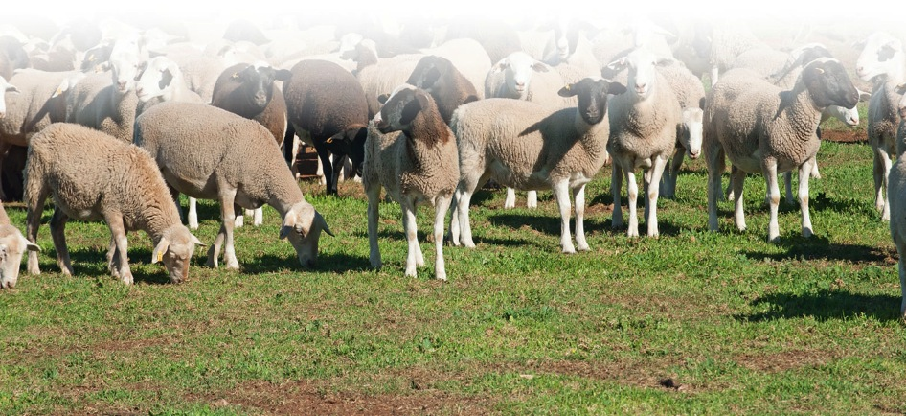

## Meat processing

There are 11 abattoirs in WA with eight licenced to export meat to various world markets, including Halal certification, and the remainder processing meat for the Australian market.

The larger abattoirs specialise in frozen or chilled cuts, while the smaller abattoirs tend to supply frozen and chilled carcass meat. Offal and skins are produced as a by-product and sold to a number of export markets.

Sheep can be sold direct to processing plants or via sheep saleyards. There are two main sheep saleyards at Katanning and Muchea, where over a million sheep are traded through an auction system annually.

WA exports a large amount of premium chilled and frozen sheep meat. China was our largest export market in 2015/16 accounting for 18% of the total volume of sheep meat exported. However, the Middle East as a region accounted for the highest total volume of sheep meat exported, as shown in Figure 2.

Figure 2 Destinations of WA sheep meat and live animals in 2015/16 by volume (head and weight) and Australian dollar value (Source ABS data, DAFWA analysis)


Figure 2Destinations of WA sheep meat and live animals in 2015/16 by volume (head and weight) and Australian dollar value (Source ABS data, DAFWA analysis)

## Live export

WA has a proud history of exporting live sheep for 100 years and Australia is the most experienced and largest exporter of live animals in the world. WA has an enviable clean animal health status supported by strict biosecurity protocols.

WA’s largest major live export market is Kuwait, taking 37% of our total live exports, followed by Qatar with 26% in 2015/16 (Figure 2).

Australia is the world leader in animal welfare systems for the export of live animals for slaughter and the only country that requires specific animal welfare outcomes for livestock export. There are two main regulatory systems; the Australian Standards for the Export of Livestock (ASEL) and the Exporter Supply Chain Assurance Scheme (ESCAS).

ASEL begins on farm in Australia and ends when the animal disembarks from the vessel in the importing country where ESCAS then takes over. ASEL is based on standard animal health and welfare requirements which ensure animals are well treated during road, air and sea transportation. Live export vessels must comply with rules regarding ventilation, stocking densities and provision of water and food.

All Australian live animal exports must comply with ESCAS, which is based on the World Organisation for Animal Health (OIE) animal welfare recommendations. All receiving facilities of importing countries must comply with these recommendations, including transport and slaughter within the importing country in order to receive Australian animals.

## Wool production

WA produces high quality fine Merino wool. The State is internationally cost competitive in wool production, handling and delivery.

WA produced 65.2 million kilograms (kg) of greasy wool in 2015/16. Over 90% is Merino wool measuring less than 24.5 micron, and was destined for high end apparel. In 2015/16, fine wool of 19.5 micron or less made up 50% of the ‘clip’ (total amount shorn).

The wool industry in WA had a gross value of $541 million in 2014/15, 53% of the total contribution of the sheep industry.

During 2015/16, there was a 5.8% increase in the volume of wool received compared to 2014/15 from 74.5 million kg to 78.9 million kg. China continues to be the major importer of Australian wool, purchasing 83% of the value of WA wool exports in 2015/16 (Figure 3).

Figure 3 Proportion of wool exported to major markets by value (A$ FOB) in 2015/16 (Based on ABS data, DAFWA analysis)


**Figure 3** Proportion of wool exported to major markets by value (A$ FOB) in 2015/16 (Based on ABS data, DAFWA analysis)

## Photo of Live Export ship.

Photo of Live Export ship.

## Quality assurance systems

WA sheep producers comply with a number of schemes that assure both the quality and safety of meat production to consumers and that animals are raised under high animal welfare standards. Schemes such as the National Livestock Identification Scheme (NLIS) and the National Vendor Declaration Scheme (NVDS) ensure that sheep sold for slaughter are free of disease and chemical contamination. The ability to trace back to the farm of origin is also possible should the need arise.

Animal welfare is protected by schemes such as the National Model Codes of Practice and guidelines such as Fit to Load that ensure that animals are fit for transport.

Eating quality is assured by Meat Standards Australia (MSA), a voluntary grading system based on consumer sensory preferences for meat quality.

Lamb graded under the MSA system is guaranteed to meet consumer expectations for tenderness, juiciness and flavour. This is achieved by a whole of supply chain approach, from breeding through to handling pre slaughter and slaughter supported by extensive research. For example, a genetics resource flock is maintained at Katanning funded by Meat and Livestock Australia (MLA) and run by the Department of Agriculture and Food, Western Australia (DAFWA). This provides sheep breeders with the information necessary to select rams superior for a range of traits including eating quality and meat yield.

## Industry growth

The value of Western Australian sheep and lamb exports have grown considerably since 2011/12. Western Australian lamb exports have increased 5% in the last financial year, and 106% since 2011/12. Since 2011/12 the value of mutton exports has increased 90% from $56.2 million to $106.5 million in 2015/16.

Globally competitive production systems, multiple trade routes, rising prices and growing demand for lamb from emerging markets bodes well for WA’s sheep industry. Australia’s low cost production systems and reputation for safe quality product has resulted in Australia being highly competitive in the global market and a leader in the global sheep trade.

Demand for Australian lamb remains high due to its reputation for producing to the highest quality with stringent animal welfare protocols and the highest food safety standards in the world. Investment in genetics, animal husbandry and pasture research has resulted in Australia having one of the lowest cost lamb production systems globally.

WA producers have access to a range of supply chains, servicing international sheep meat and live export markets, with established trade routes to more than 100 countries as well as domestic markets. This significantly reduces the market risk for sheep producers and also facilitates a competitive bidding environment for sheep, placing upward pressure on prices. Furthermore, WA has an international cost advantage being located closer to growing Asian markets than other exporting competitors.

Figure 4 The value (A$ FOB) of WA mutton and lamb exports (ABS data, DAFWA analysis)


**Figure 4** The value (A$ FOB) of WA mutton and lamb exports (ABS data, DAFWA analysis)

## Sheep Industry Business Innovation

The Department of Agriculture and Food, Western Australia manages the Sheep Industry Business Innovation (SIBI) project, which is a four-year project made possible by the State Government’s Royalties for Regions investment. The high priority activities being undertaken in order to produce a more profitable and resilient sheep industry tuned to customer needs include:

• Supporting the establishment of dedicated export supply chains.

• Increasing the on-farm productivity of market-preferred products, through better genetic selection and higher stocking and reproductive rates.

• Improving business performance by improving farm business and production skills.

• Increased access to investment as a result of increased confidence in the industry and more attractive business models for investors.

### The Sheep Alliance

The Sheep Alliance of WA, formerly called Sheep Industry Leadership Council, is a not for profit incorporated association that was formed in July 2016. It aims to prepare a whole-of-supply chain response to the decline in WA sheep population, drive sheep business profitability and sustainable industry growth.

Membership of the Alliance is open to all entities that are key contributors to the sheep supply chain and/or are actively working towards improving the profitability of the WA sheep industry. The membership base is diverse, bringing together growers, sheep exporters, wool exporters, processors, universities and educational institutions, wool and livestock brokers, agricultural consultants and various other service providers supporting the sheep industry.

SIBI, through its Industry Leadership and Development subproject, supports the Sheep Alliance as the peak leadership body and an advocate of change management for the WA sheep industry.

Figure 5 Western Australia’s sheep meat value chain


**Figure 5** Western Australia’s sheep meat value chain

## For more details

[Sheep meat and wool industry facts](https://www.agric.wa.gov.au/sheep/western-australian-sheep-and-wool-industries)   
agric.wa.gov.au/sheep/western-australian-sheep-and-wool-industries

[Sheep Industry Business Innovation](https://www.agric.wa.gov.au/r4r/sheep-industry-business-innovation-project)   
agric.wa.gov.au/sibi

## Important disclaimer

The Chief Executive Officer of the Department of Agriculture and Food and the State of Western Australia accept no liability whatsoever by reason of negligence or otherwise arising from the use or release of this information or any part of it.

Copyright © Western Australian Agriculture Authority, 2016

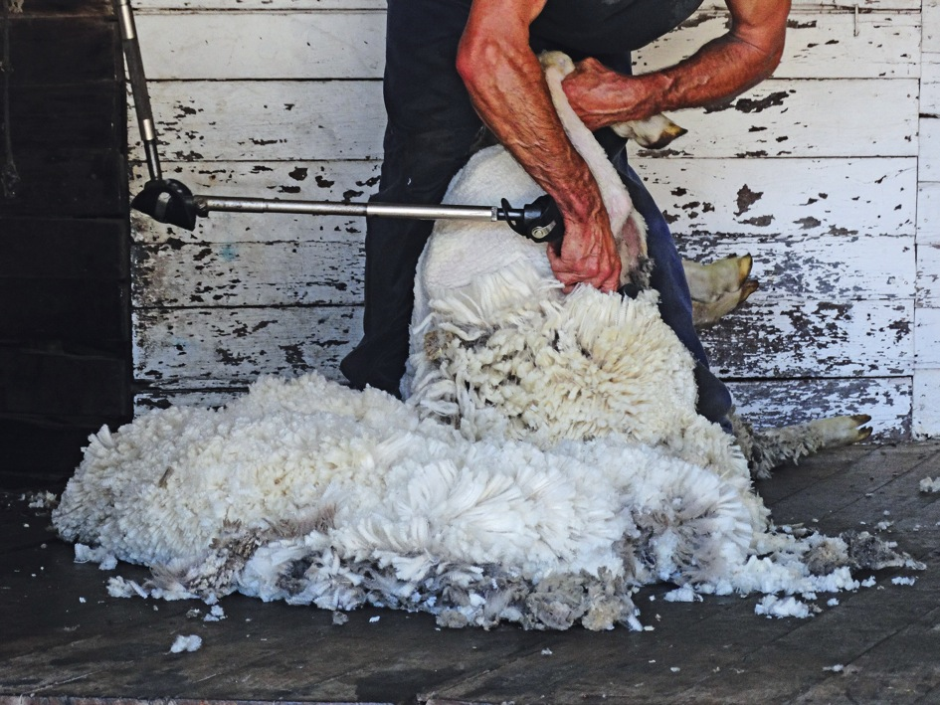

This project is made possible by the Royalties for Regions investment.

