**PILBARA REGIONAL**

**BIOSECURITY GROUP INC.**

**ANNUAL REPORT 2014/15**

**1. INTRODUCTION**

**About the Pilbara Regional Biosecurity Group**

The Pilbara RBG is a not for profit association formed under the *Associations Incorporation Act* 1987, providing declared pest control programs for land managers, particularly in the pastoral zone. The associations’ primary purpose is the control of declared pests using funding from Declared Pest Rates paid by landholders on pastoral stations. These Declared Pest Rates funds are matched dollar for dollar by the WA Government to reflect the public benefit of controlling declared pest animals and weeds. The association is formally recognised by the Hon Minister for Agriculture and Food as a recognised biosecurity group (RBG).

**Membership of the Association**

Full membership of the Association is open only to ratepayers within the area and full membership is automatically bestowed upon the individual or entity in whose name the relevant Declared Pest Rate assessment is issued, provided also that the relevant assessment is paid in full within 12 months of its issue date.

**Committee of management members (as at 30 June 2015)**

|  |  |  |
| --- | --- | --- |
| **OFFICE HELD** | **OFFICE HOLDER NAME** | **LOCATION** |
| **Chairperson** | Geoff Mills | Wallal Downs Station, Port Hedland |
| **Vice Chairperson** | Annette Mills | Warrawagine Station, Marble Bar |
| **Treasurer/Secretary** | Kim Parsons | Coolawanyah Station, Tom Price |
| 1. Full Member | Jamie Richardson | Mt Florence Station, Tom Price, |
| 1. Full Member | Digby Corker | Red Hill Station, Pannawonica |
| 1. Full Member | Vacant |  |
| 1. Full Member | Vacant |  |
| 1. Associate Member | Andrew Turner | Rio Tinto Pastoral, Tom Price |
| 1. Associate Member | Ian Cotton, Project Manager/delegate Pilbara Corridors Project | Como WA |
| 1. Associate Member | Nigel Wessels, Regional Manager/delegate  Department of Parks and Wildlife | Karratha, WA |
| 1. Associate Member | Linda Anderson, Project Manager/delegate Pilbara Mesquite Management Committee | Karratha, WA |

**How the group is funded**

The Pilbara RBG’s main source of funding is from Declared Pest Rates paid by pastoral leases that are matched equally by the WA State Government. The Pilbara RBG also partners with the Pilbara Corridors Project and the Department of Parks and Wildlife (DPaW), with operational support and agreements with DAFWA, to undertake donkey collaring control programs and opportunistic aerial culling of camels and feral horses. DPaW also contribute to wild dog aerial baiting on wild dog leads (movement corridors) from pastoral stations into DPaW managed properties.

**2. PILBARA RBG AIMS AND AREA OF OPERATIONS**

The Pilbara RBG aims to:

* Foster the control of declared pests throughout the Pilbara, via the formulation, implementation, and review of appropriate management plans and programs;
* Encourage integration, coordination, and general collaboration of Pilbara stakeholders in pest management matters;
* Promote the adoption of best practice invasive species control throughout the area.

The Pilbara RBG annual operational plan for 2014/15 focused on minimising the impact of declared weeds and pests on industry, environment and the community. This is primarily delivered through funding for:

* An annual community aerial baiting program for wild dogs. Landholders are also encouraged to undertake ground control as a primary method of wild dog management;
* A Radio Telemetry program for Feral Donkey control in the east and central Pilbara; and
* Working with Pilbara Mesquite Management Committee in the management of Mesquite and Parkinsonia; providing herbicide and sprayers for declared plant control programs.

These activities provided pastoral businesses the bare minimum level of control required to prevent negative impacts of priority declared pests.

**Area of operation**

The Pilbara Regional Biosecurity Group Inc (Pilbara RBG) region includes four local government areas - the City of Karratha, Shires of Ashburton and East Pilbara and the Town of Port Hedland. The major towns of the region are Port Hedland and Karratha. Other towns are Roebourne, Dampier, Onslow, Pannawonica, Paraburdoo, Tom Price, Wickham, Newman, Marble Bar and Nullagine. The Pilbara RBG region extends east to the Northern Territory border and includes Jigalong and other Aboriginal communities in desert country. The region also includes pastoral stations along Eighty Mile Beach – Pardoo, Wallal Downs, Mandora and Anna Plains. There are about 60 pastoral leases in the area.

Map showing Pilbara RBG region in relation to other RBGs in Western Australia

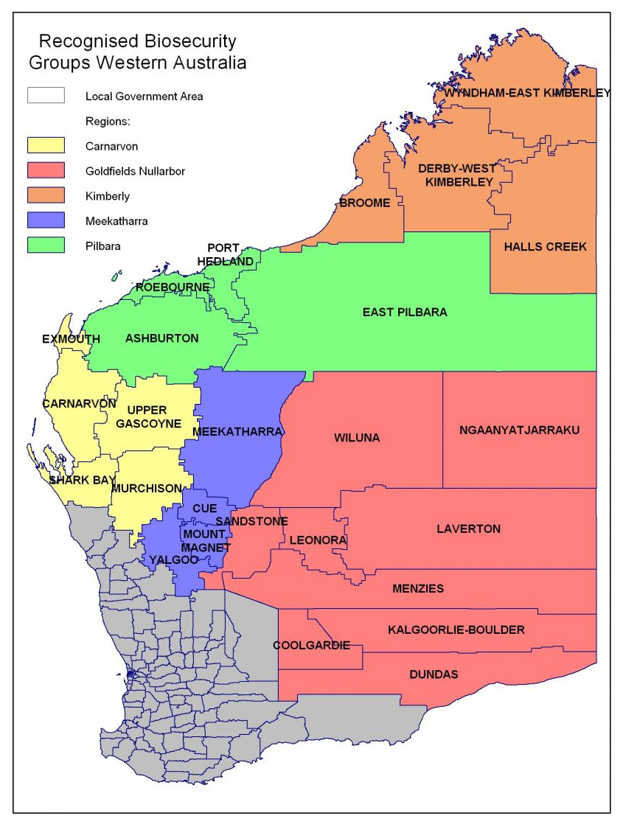

**3. PILBARA RBG OPERATIONS 2014-15**

The Pilbara RBG has a Declared Pest Account into which the Department of Agriculture and Food WA (DAFWA) deposits the declared pest rates paid by pastoralists and the government’s matching contribution. The Pilbara RBG also partners with the Pilbara Corridors Project and the Department of Parks and Wildlife (DPaW), with operational support and agreements with DAFWA, to undertake donkey collaring control programs and opportunistic aerial culling of camels and feral horses. DPaW also contribute to wild dog aerial baiting on wild dog leads (movement corridors) from pastoral stations into DPaW managed properties.

In 2014/2015, operational income (excluding GST) was:

| * Operational Funding | $512,750.77 |
| --- | --- |
| * Executive Support | $5,000.00 |
| * Interest Received | $2,425.13 |
| * Other Income | $0 |
|  |  |
| **Total Operating Income** | **$520,176** |

2014/15 operational activities and expenditure covered:

| * Advertising and promotion | $232.40 |
| --- | --- |
| * Audit fees | $1,500.00 |
| * Baits, Collars and Traps | $129,287.20 |
| * Bank Fees And Charges | $5.75 |
| * Bookkeeping expenses | $1,808.00 |
| * Contract payments | $50,062.83 |
| * Fuel & oil | $15,213.66 |
| * Helicopter charter | $138,797.27 |
| * Insurance | $3,800.68 |
| * Sundry expenses | $59.70 |
|  |  |
| **Total Operating Expenses** | **$340,767.49** |
|  |  |
| **Surplus from ordinary activities** | **$179,408.41** |

During January to June 2015 large feral herbivore control work, mainly through the donkey collaring program was significantly reduced due to DAFWA capacity issues. Most of the budget surplus was from unspent helicopter charter and related fuel. The Pilbara RBG has reviewed the donkey collaring program and will look for opportunities to spend this budget surplus on expanding the donkey collaring program in the western/southern Pilbara region.

The Pilbara RBG relies heavily on pastoral lease holders to play an active role in undertaking pest animal and plant control on their own stations as part of their individual responsibility to manage pests. The Pilbara RBG also relies on members from each pastoral station to distribute dried meat baits across their station(s), trap/shoot wild dogs where required, and to monitor and report on sightings of large feral herbivores, including donkeys, camels and feral horses on their properties.

Voluntary roles performed by Pilbara RBG members include:

* Participation on the Management Committee;
* Distributing dried meat baits across their station(s);
* Trapping and/or shooting wild dogs where required; and
* Pastoral stations making airstrips available for the aerial baiting plane use, along with providing meals and overnight accommodation for the pilot during aerial baiting programs.