Investor-Ready Sheep Feedlot Project

A Sheep Industry Business Innovation Project
Department of Agriculture and Food, WA

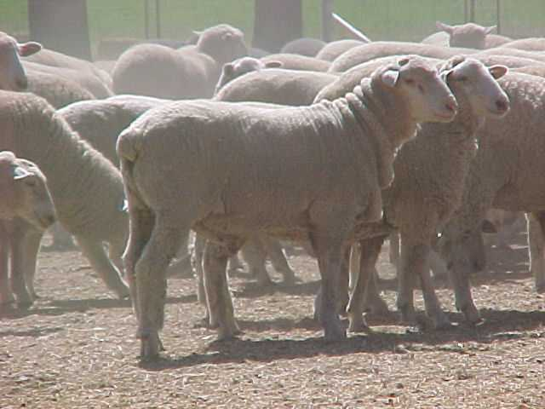

Compiled by:

Geoff Duddy
Sheep Solutions
‘Thorley’
Omanama Qld 4352
(0427) 007490
geoff@sheepsolutions.com.au

Contents
Investor-Ready Sheep Feedlot Project - Overview 2
Executive Summary 3
WA Sheepmeat Industry Review 5
Strengths, Weaknesses, Opportunities and Threats (SWOT) Analysis 6
Sheepmeat Price Variabilities and Patterns 8
Model Farm 13
Feedlot Calculator Analysis Assumptions: 16
Infrastructure Costs and Assumptions: 17
Analysis Outcomes/Discussions: 19
Feedlot Capacity versus Feedlot Maximum Annual Throughput 19
Feedlot Capacity versus Feedlot Maximum Throughput impacts on Fixed Costs and Purchase Price input cost share 19
Profitability of finishing lambs in large-scale feedlot (5000 to 50 000 head) systems 21
Appendix 1 Scope of Works Overview 24
Appendix 2 Curriculum Vitae (Geoff Duddy) 27
Appendix 3 Curriculum Vitae (David Zinga) 29
Appendix 4 -Sheep CRC Feedlot Calculator 31
Appendix 5 Analysis Assumptions and costings 32
Appendix 6 Sensitivity Analysis investigating the change in profitability of five feedlot systems 40
Appendix 7 WA feedlot profitability under three Restocker/Feeder and Trade lamb category price scenarios 41
Appendix 8 Feedlot pen and proposed 5000 head Feedlot ‘module’ design 45
References: 47

Investor-Ready Sheep Feedlot Project - Overview
Background
The Sheep Industry Business Innovation project aims to develop technical and business information and facilitation of new sheep value chains within Western Australia (WA). The Investor-Ready Sheep Feedlot project seeks to determine establishment costs, infrastructure requirements, environmental impact and effluent management assessments and a benefit/cost feasibility study for a low-input, large-scale (from 10 000 to 50 000 head) commercial sheepmeat feedlot.
This preliminary study will inform a larger report and analysis on the returns on investment (ROI) of a range of sized feedlots and locations within WA.
Objectives

- A desktop report on the infrastructure required, including water, power and effluent disposal and the indicative costs of construction for a commercial grade, low labour sheepmeat feedlot for 10 000, 20 000, 30 000 and 50 000 head.

Completed by Geoff Duddy (Sheep Solutions) and David Zinga (Zinga and Associates).
Feedlot site development, manure and effluent management etc are included as a separate document.

- A desktop analysis on feedlot profitability for feedlots of 10 000, 20 000, 30 000 and 50 000 head with respect to feed prices and the purchase and turnoff price for stock.

Completed by Geoff Duddy (Sheep Solutions).
*Note: Objective 2 was modified as part of the project submission to include smaller (5000 head) systems.

This report should be read in conjunction with
- National procedures and guidelines for intensive sheep and lamb feeding systems (Dickson and Jolly, 2011) http://productivenutrition.com.au/index.php/Table/Independent-Livestock-Nutrition-and-Business-Management-Advice-to-Producers-and-Industry-across-Australia/
- National procedures and guidelines for intensive sheep and lamb feeding systems Planning and management checklists: a review tool for producers (Dickson and Jolly, 2011) https://static1.squarespace.com/static/5371735ee4b0edb14ea92086/t/538fa45be4b056260cc42af5/1401922651842/National+procedures+and+guidelines+lamb+finishing+-+checklists.pdf

Executive Summary
Sheep Solutions successfully tendered for the Sheep Industry Business Innovation “Investor-Ready Sheep Feedlot Project” in February 2017. The project involves a desktop analysis to determine establishment costs, infrastructure requirements, environmental impact and effluent management assessments and a benefit/cost feasibility study for low-input, large-scale (5000 to 50 000 head) commercial sheepmeat feedlots in WA.
Industry representatives, including nine (9) sheepmeat feedlot owners/managers from within WA and eastern states, were contacted prior to, and during, the course of preparing the following report to determine potential management and operational issues faced by large-scale operations. All assumptions used to generate data and relevant costings are discussed in detail.
An analysis of WA Restocker/Feeder and Trade lamb market prices/patterns/relative values, the profitability and cost/benefit of feedlotting and a thorough sensitivity analysis were undertaken.
Report findings suggest:
- The profitability of finishing lambs is heavily influenced by:
  - the value of Restocker/Feeder lambs relative to the finished Trade lambs
  - throughput, with operations finishing lambs at or close to their maximum annual throughput having lower depreciation on capital ‘cost’ and greater profit margins
  - the timing of purchase and marketing of the finished lamb.
- The profitability of finishing lambs is also influenced to a lesser degree by:
  - feed prices
  - establishment cost
  - operational scale, with larger operations likely to return greater profits per lamb than smaller (5000-10 000) systems.

Risk must be factored in if considering the establishment of larger scale operations. The report’s analyses suggest very low returns (profits) under most scenarios based on the assumptions used.
Recommendations in relation to future development of large-scale feedlot systems within WA include:
- A thorough cost/benefit analysis should be conducted prior to feedlot development regardless of scale.
- Analysis of Restocker/Feeder to Trade lamb ‘relativities’ should be factored in to any feedlot system budgeting analysis. Under the scenarios and systems analyzed the greatest influence on profit was the Restocker/Feeder lamb starting value relative to Trade lamb values. Small profits were possible provided the Restocker/Feeder to Trade lamb ‘relativity’ was 86% or lower.
- Maximizing lamb throughput (regardless of the feedlot operational capacity and/or the establishment cost) is strongly recommended if choosing to finish lambs on a commercial scale due to the impact that fixed costs have on system profitability. Increasing throughput significantly reduced depreciation cost on capital when costed as a $ per lamb value, produced higher profit margins (or lower losses), and reduced margins between ‘capacity’ and ‘maximum’ profit range as operational size increased.
- Ration cost had little impact on the change in profit margin generated.
- Greater emphasis should be placed on modifying lamb supply patterns to minimize seasonal price variations.
- Consideration should be given to the:
  - development of producer run smaller scale (3000 to 5000 head) feedlot systems with minimal infrastructure cost, reducing operational and financial risk
  - development of small (3000 to 5000 head) to medium (10 000 to 20 000 head) scale producer/feedlotter alliances to ensure continuity of supply and quality control within producer operated systems
  - development of medium scale (10 000 to 20 000 head) feedlot systems supported by processor bodies responsible for coordinating lamb supply, reducing operational and financial risk
  - development of medium scale (10 000 to 20 000 head) feedlot systems paid a management fee to finish lambs sourced/supplied by processor bodies, reducing operational and financial risk
  - development of large-scale (30 000+ head) feedlot systems by processor bodies who are responsible for coordinating lamb supply and operational/financial risk
  - development of processor/feedlotter producer alliances based on contract backgrounding of lambs prior to feedlotting. Such alliances would be of greatest benefit during the spring lamb price trough period when a majority of annual lamb purchases could be made and stubble, summer forages, and perennials could be utilized.

WA Sheepmeat Industry Review

The following, taken from “Seasonality of Lamb Supply – Have We Interpreted the Price Signals?” (Young 2016), provides an overview of WA lamb production systems and commentary relevant to the following report:

The lamb production system in WA is characterised by a large supply of lambs finished on green feed during spring and a reduction in supply through summer, autumn and winter. This pattern of supply reflects the cost of finishing the lambs, with it being cheapest finishing on green feed and progressively more expensive as the season progresses. Higher prices are offered for out of season lamb, however, historically these premiums have not been sufficient to entice farmers away from the sucker lamb production system.

The change in profitability from delaying the turn-off of carryover lambs is a trade-off between:
- The change in price received for the lamb
- The amount and quality of feed required for backgrounding and finishing the lamb and the timing of the demand
- Husbandry cost and labour
- Wool Income (delaying the sale of carry-over lambs increases the quantity of wool grown) and
- Death Rates

This analysis indicates that a price increase of $0.30 to $0.35/kg DW/month is required in order for farmers to make equal profit from turning off lambs later.

Furthermore, a larger price increase per month than that calculated may be required to achieve practice change on farm because of the risk associated with carrying the lambs longer.

The risks include both production and market risk. The production risk includes risks associated with animal health and increased death rates or reduced rate of live weight gain in the feedlot. The market risk includes risks associated with the price of grain required for feedlotting and also the price received for the lamb. This later risk could be reduced if processors introduced a strong forward pricing mechanism that farmers believed and could plan their production around.

Strengths, Weaknesses, Opportunities and Threats (SWOT) Analysis

The following SWOT analysis relates to the development and use of large-scale sheepmeat feedlot systems within WA. It is not, and should not, be seen as an exhaustive list nor should the order of each point be seen as order of significance and/or impact.
Many of the points shown can be supported by findings of this report.

Strengths:
- efficient production methods
- economy of scale
- best practice
- Australia’s Clean and Green/Quality image
- producer intentions to increase lamb production and supply
- current low grain values, reducing ration costs relative to other feedlot inputs
- greater use/experience of on-farm grain finishing systems compared to other states
- processor (pellets, sheepmeat) number and options
- market access and options (traditional markets, live sheep etc)
- reduced air freight costs to major markets compared to eastern states.

Weaknesses:
- volatile global commodity markets
- current lamb supply (number and seasonality)
- high starter lamb prices relative to finished lamb prices
- limited large scale (30 000) operations to draw expertise/knowledge from
- limited recording system(s) for production efficiency monitoring and financial analysis
- skin returns
- water quality and supply consistency
- feedlot infrastructure costs required to meet best practice requirements, minimize costs and maximize production
- transport distances for inputs (sheepmeat, ration components etc) and product (sheepmeat) if finishing system located outside the Great Southern region.

Opportunities:
- increase domestic/export demand and market share
- potential market development
- improvements in production and finishing efficiencies
- increased consumer demand
- reduce feed ration costs through supplying grain to pellet manufacturers in return for reduced pellet cost
- value add potential for all inputs (producers’ lamb, grain, fibre etc)
- walk over weighing and use of EID to monitor lamb performance and identify producers with better performance/genetics etc
- producer alliance development with opportunities to improve on-farm and feedlot performance through providing feed conversion, growth rate and efficiency feedback
- consistency of supply
- product consistency.

Threats:
- environmental issues/potential for contamination (real and perceived)
- consumer perception re poor conversion of grain to meat
- input prices specifically ‘starter’ lamb values relative to finished lamb returns
- continued high demand and prices paid for ‘Shipper’ and ‘Bag (Muslim Kill, airfreighted)’ lamb
- health and disease risk
- animal activists
- climate change/variability (eg drought) impacting on production of inputs (lamb, feed components etc)
- WA cropping focus impact on sheep/lamb production intentions.

Sheepmeat Price Variabilities and Patterns
Nationally we are currently experiencing high prices despite reasonably high slaughter (supply) rates. While WA producers have limited control over lamb prices, supply patterns, and the trading environment faced by processors, they do have flexibility in terms of their marketing options (bagged ‘Muslim Kill’ through to heavy export weight carcasses). Decisions with respect to market segment(s) targeted are heavily influenced by current and predicted price patterns, seasonal conditions and/or input costs if electing to finish lambs to heavier weights.

The starting value of lambs entering a feedlot is the major production cost. Producers finishing ‘own bred’ lambs need to be mindful of the opportunity cost of valuing lambs entering a feedlot system founded on an individual Cost of Production (CoP) basis. CoP for Restocker/Feeder (16-18kg HSCW) Merino and Crossbred lambs generally range between $55 to $75 per lamb. These values are significantly lower than market value for this article and may distort actual feedlot profit margins and value adding estimates.

Figure 1 depicts the saleyard values of WA Restocker/Feeder and Trade lamb categories since 2010. The average annual difference between these categories during this period is +19c/kg (annual average range of +2 to +45c). Note that the relative difference between these categories has tightened and the price received has increased since late 2016.

Figure 1: WA Restocker/Feeder and Trade lamb values (2010-May 2017) with a 30-day data set moving average (simulating monthly price cycles)

Figure 2 illustrates price variation on a percentage basis for Restocker/Feeder, Trade and Merino Lambs for the period 2010 to May 2017. Note that ‘100%’ relates to the average value for the respective categories across the period shown. Values above ‘100%’ indicate periods during which prices received generally fall above the annual average. Solid lines represent a ‘4 point (ie monthly) moving average’ while dotted lines indicate weekly price variation for each category. These values do not indicate likely profitability, merely price received for the traded product.

Figure 2: WA Trade, Restocker/Feeder and Merino lamb annual price variation for the period 2010 to May 2017

From Figure 2 we can see that historical price peaks and troughs for:
- Restocker/Feeder are +7% (April) and -10% (November)
- Trade lambs are +11% (July) and -17% (November) and
- Merino lambs are +33% (July) and -56% (January) respectively.

Restocker/Feeder lambs therefore have a ‘tighter’ price variation range (17 percentage units) than Trade lambs (28 percentage units) for the period analysed.

While WA Merino lamb (16-22kg) price variations follow a similar pattern to both Trade and Restocker/Feeder lamb categories, the range between historical average price peaks and troughs (+33% in July and -56% in January) are far greater than Restocker/Feeder or Trade lamb categories and make forecasting profitability of finishing these lambs within a feedlot far more difficult.

Figure 3 illustrates the relative percentage value of WA Restocker/Feeder lambs (17-18kg) compared to Trade (22kg+) weight lamb values 8 weeks later. This allows for estimates of finished lamb values (if contract prices are unavailable) based on historical price variation once Restocker/Feeder values are known. Note that a value of 100% is the point at which Restocker/Feeder and Trade lamb values are the same on a c/kg basis.

Figure 3: WA Restocker/Feeder versus Trade lamb relativities (2010 to May 2017)

From Figure 3 we can see that Restocker/Feeder lamb values ‘relative’ to Trade lambs have consistently traded at or above 85% since June 2014. For the period shown ‘relativity’ averaged 94% (range 62-153% on a weekly price basis, 84 to 98% on an annual average basis).
If the expected average price for Trade lambs in 2017 is 580c/kg ($133.40 including skin) and the relative price for Restocker/Feeders remains at 94% of the Trade value, the Restocker/Feeder average price would be expected to be ~545c/kg or $92.65.

The price of the lamb (on entry) ‘relative’ to the finished lamb has a major impact on profit margin. This ‘relative percentage value’ generally needs to be below parity to minimise risk and achieve reasonable profit margins.

For example:
- A 17kg Restocker/Feeder lamb, $95 landed on-farm has a c/kg value (skin included) of ~560c/kg ($95/17 = 560c/kg).
- A 23kg Trade lamb sold for $150 (gross value, skin included) = $150/23 or ~650c/kg.
- The Restocker/Feeder lambs relative to Trade lambs value = 560c/650c or 86%.
- Using 2017 WA average values (561c and 589c/kg for Restocker/Feeder and Trade lambs; relativity of 95%), a $290/t pelleted ration plus hay ($100/t), operating costs and losses (deaths, shy feeders, feed wastage etc) would generate a loss of $1.57 per lamb compared to selling the Restocker/Feeder lambs.
- The breakeven ‘relativity’ would occur at 93.5% or 551c/kg ($93.67) for the Restocker/Feeder.
- Restocker/Feeder lamb value and feed costs represent 70 and 17.7% respectively of total costs in the above scenario.

We must also consider seasonal variation in lamb category prices given that without contracts in place there will be periods when the Restocker/Feeder lamb prices are high relative to the finished Trade lamb values, reducing the likelihood of profit and increasing enterprise risk.

Figure 4 illustrates variation across the season when looking at Restocker/Feeder lamb values relative to Trade sale values eight weeks later (when Trade lambs are marketed).

Figure 4 WA seasonal ‘relativities’ between Restocker/Feeder and Trade lamb values
(2010 to May 2017)

High risk purchasing periods fall from late autumn (May) through to early spring (September) when Trade lamb values are generally declining due to pressure from increased supply. Average seasonal ‘relativities’ for the period 2010 to 2017 are 89%, 90%, 107% and 88% for summer/autumn/winter and spring periods respectively.

Mutton, as for all lamb categories, experiences supply shortages mid-year and excess during latter months. This has a major impact on mutton value variation across the year as illustrated in Figure 5.

Figure 5: WA Mutton Price Variation patterns (1998-2016)

So, what does this all mean?
- Day to day lamb prices vary but historical price patterns can indicate the price peaks and troughs of selected lamb categories.
- Restocker/Feeder lambs have a similar annual price variation/pattern as Trade lambs (Figure 2) with lower peak and trough percentage values.
- The trough (November) for Trade lambs is ~17% below the average annual price. This is driven principally by lamb supply as described by Young (2016).
- Comparing Restocker/Feeder prices to finished Trade lamb returns 6-8 weeks after purchasing the ‘starter’ lamb can generate a ‘relativity’ value. This ‘relativity’ can be used to pre-determine the likelihood of reasonable profit within feedlot systems.
- ‘Relativities’ are variable particularly when assessed on a seasonal basis. This is obvious when looking at Figure 4 where Restocker/Feeder lamb purchases during winter are risky if considering finishing them within a feedlot system.
- Merino lamb annual price variations have a far greater ‘spread’ than the Restocker/Feeder and Trade lamb categories. This further exacerbates difficulties with predetermining likely profitability if finishing these lambs in a feedlot system.
- Mutton numbers and values vary considerably with historical price peaks occurring in July and troughs during late spring. Scope for finishing mutton within feedlot systems is limited in terms of profitability other than prior to the winter price peak.

Model Farm
A representative ‘model’ farm unit was generated to allow a standard base from which the various feedlot scenarios could be analyzed.
A 5000-head capacity feedlot ‘module’ was designed comprising:
- 10 production and 2 sick pens per 5000 lambs with associated earthworks & drainage, fencing, feed and water systems, water supply, on-site storage and reticulation, solid (carcass composting, manure management) and liquid waste management (sedimentation basins, holding ponds etc) areas
- site access, internal roads etc
- sheep/lamb receival, induction, drafting and transport facilities
- feed delivery and storage facilities (sheds and silos)
- workshop, machinery sheds, chemical storage, office and staff amenities.

Details and assumptions on which the ‘model’ farm was based are listed below:

Region: Great Southern
Local government area: Shire of Broomehill-Tambellup
Farm area: 1800 hectares (4500 acres)
Principal industries: Cereals (65% arable area)
Grazing (balance of property)

Existing infrastructure: 36m*15m 3 stand shearing shed (replacement cost $220/ m$²$ =
540m$²$*$220 = $119,000)
Steel sheep yards (3500 head capacity; $12,000)
2 20*30m hay sheds (3 bays/shed)
Grain silos (total capacity 300 tonnes; used, $15,000)
Machinery: Tractors (2) – 125hp (used; $33,000) and 85hp (new; $45,000)
2 Grain augers (used; 8” *30’, $4500/$6500)
Grouper (capacity 15 tonne; used, $35,000)
Reasoning:
- The ‘model’ farm’s proximity to:
  - Cooperative Bulk Handling receival site
  - Major abattoirs at Bunbury, Katanning, Albany, Narrogin and Kojonup
  - Katanning Saleyards:
    - largest undercover complex in southern hemisphere
    - capacity 26,000 /sale (average yarding is ~12,000-15,000)
    - capable of trading 12 million sheep annually
    - most sales comprise ~30% crossbred lambs, 20% Merino lambs and 50% mutton
    - approximately 40% of lambs per sale are returned to farms or feedlots.
- High stocking rates, good with regard to regional lamb supply.
- Grazing options include canola/cereals in winter/spring; stubbles and fodder crops over summer allowing Restocker/Feeder lambs purchased in spring to be carried over/lot fed.
- Access to Great Southern Water Scheme (stock and domestic) and Farm Water Rebates to implement on-farm water improvements.
- Environment
  - winter dominant rainfall pattern
    - Mean rainfall 455mm
    - Mean days > 10mm 13.3
  - mild to warm seasonal conditions
    - Maximum Winter 14.7 (July) Summer 30.1 (January)
    - Minimum Winter 5.9 (July) Summer 14.1 (February)
    - Days >35° 17.6
    - Days < 2° 10.7

- Soil characteristics:
  - solonised brown soils - clay with a shallow surface horizon of sandy clay loam
  - the surface soil is typically hardsetting and often has quartz gravels on the surface
  - level to gently sloping valley floors and lower slopes; waterlogging and shallow inundation can occur on flat areas
  - high alkalinity and sodicity
  - slow drainage of water into shallow subsoil material
  - soil water storage is good. Dams and natural catchments perform well.

Statistics | Jan | Feb | Mar | Apr | May | Jun | Jul | Aug | Sep | Oct | Nov | Dec | Annual
Mean maximum temperature (°C) | 30.1 | 29.7 | 27.1 | 23.3 | 19.2 | 16.0 | 14.7 | 15.4 | 17.4 | 21.9 | 26.2 | 28.5 | 22.5
Highest temperature (°C) | 43.6 | 41.0 | 40.0 | 35.5 | 31.0 | 23.0 | 22.0 | 24.4 | 31.0 | 36.0 | 41.0 | 43.0 | 43.6
Lowest maximum temperature (°C) | 16.0 | 15.3 | 14.0 | 13.0 | 10.7 | 10.0 | 9.0 | 9.9 | 9.7 | 12.0 | 13.0 | 14.0 | 9.0
Mean number of days ≥ 30 °C | 15.7 | 12.9 | 7.9 | 2.4 | 0.2 | 0.0 | 0.0 | 0.0 | 0.1 | 2.1 | 7.6 | 11.7 | 60.6
Mean number of days ≥ 35 °C | 5.9 | 4.1 | 2.7 | 0.1 | 0.0 | 0.0 | 0.0 | 0.0 | 0.0 | 0.2 | 1.8 | 3.8 | 18.6
Mean number of days ≥ 40 °C | 1.0 | 0.2 | 0.1 | 0.0 | 0.0 | 0.0 | 0.0 | 0.0 | 0.0 | 0.0 | 0.1 | 0.8 | 2.2
Mean minimum temperature (°C) | 13.7 | 14.1 | 13.0 | 11.1 | 8.7 | 6.8 | 5.9 | 6.0 | 6.1 | 7.5 | 10.1 | 11.7 | 9.6
Lowest temperature (°C) | 6.0 | 6.0 | 4.5 | 4.0 | 0.8 | -0.2 | -2.0 | -1.0 | -2.0 | -0.7 | 0.0 | 3.0 | -2.0
Highest minimum temperature (°C) | 26.1 | 25.0 | 25.0 | 19.0 | 18.0 | 13.0 | 12.3 | 15.0 | 15.6 | 17.0 | 23.0 | 23.0 | 26.1
Mean number of days ≤ 2 °C | 0.0 | 0.0 | 0.0 | 0.0 | 0.2 | 1.1 | 2.8 | 2.5 | 2.4 | 1.4 | 0.2 | 0.0 | 10.6
Mean number of days ≤ 0 °C | 0.0 | 0.0 | 0.0 | 0.0 | 0.0 | 0.1 | 0.4 | 0.1 | 0.3 | 0.1 | 0.1 | 0.0 | 1.1
Mean rainfall (mm) | 23.6 | 14.3 | 22.0 | 30.4 | 48.9 | 57.3 | 61.5 | 60.2 | 53.6 | 30.8 | 23.4 | 27.1 | 454.8
Highest rainfall (mm) | 98.0 | 172.8 | 86.4 | 102.4 | 180.0 | 133.2 | 105.0 | 86.4 | 123.6 | 76.8 | 76.4 | 82.8 | 668.4
Lowest rainfall (mm) | 0.2 | 0.0 | 1.0 | 2.0 | 5.2 | 19.4 | 22.8 | 9.0 | 19.8 | 4.8 | 1.8 | 0.2 | 289.8
Mean number of days of rain | 3.9 | 2.9 | 5.4 | 7.4 | 12.6 | 16.2 | 19.5 | 19.1 | 16.9 | 9.5 | 6.5 | 4.2 | 124.1
Mean number of days of rain ≥ 1 mm | 2.0 | 1.3 | 2.9 | 4.4 | 6.1 | 8.8 | 10.4 | 9.3 | 8.9 | 5.4 | 4.0 | 2.6 | 66.1
Mean number of days of rain ≥ 10 mm | 0.9 | 0.3 | 0.7 | 0.7 | 1.5 | 1.7 | 1.8 | 1.7 | 1.8 | 0.8 | 0.7 | 0.7 | 13.3
Mean number of days of rain ≥ 25 mm | 0.3 | 0.2 | 0.2 | 0.3 | 0.2 | 0.2 | 0.1 | 0.3 | 0.1 | 0.2 | 0.2 | 0.4 | 2.7
Mean daily solar exposure (MJ/m²) | 28.0 | 24.5 | 19.3 | 14.0 | 10.3 | 8.6 | 9.2 | 11.8 | 15.8 | 21.1 | 25.2 | 28.2 | 18.0

Source: http://www.bom.gov.au/climate/averages/tables/cw_010916_All.shtml
Site (Katanning Latitude: 33.69° S, Longitude: 117.61° E)

Feedlot Calculator Analysis Assumptions:

Five (5) ‘base’ feedlot systems were analyzed using the Sheep CRC Feedlot Calculator (refer Appendix 4) and Excel software developed during the course of this report.

Capacity of systems analyzed were 5000, 10 000, 20 000, 30 000 and 50 000 head.
Maximum annual throughput for these systems was 43 333, 86 667, 173 333, 260 000 and 433 333 respectively based on feedlot capacity, deaths and shy feeder numbers.

Lamb and ration information were constant across all five systems.

Input data included:
- Breed/Cross Crossbred lambs
- Starting weight 38kg live
- Carcass weight 17kg HSCW
- Starting value $93.65 (551c/kg including skin value)
- Target Final weight 50kg live
- Target Carcass weight 23kg HSCW
- Final value $133.40 (580c/kg including skin value)
- Growth rate 280g/h/d
- Finishing time 43 days (plus 2 week ‘introduction’ period)
- Daily Intake (% of live weight) 3.5%
- Feed Conversion 6.1:1 (as fed basis)
- Total average feed per lamb 77kg (as fed)
- Ration 90% pellets/10% cereal or pasture hay
- Ration Values
      - Energy 12.7Mj/kg of Dry Matter
      - Protein 16.1Mj/kg of Dry Matter
      - Dry Matter 90%
- Ration Cost $298/tonne (as fed)
- Deaths/Shy Feeders/Sale percentages 1%, 5% and 94%
- Interest on purchased lambs 8%
- Lambs 2-4 weeks off-shears when purchased
- Animal Health Lambs given drench/Vitamin A, D, E and
B12 and clostridial vaccinations on delivery.
Treatment costs of ill lambs while
within the feedlot have not been costed as
these would be considered minor under best management practice.
- Transport costs $2/head (in) $3/head (out)
- Slaughter levy $1.50 per head
- Sale commission 5.5%
- Feed out losses 5% (for both pellet and hay)
- Base labour cost per lamb 5c/lamb/day (self-feeder system). Calculated
by estimating time needed for all feedlot
operations/week x $cost of labour per hour per number of days x number of lambs.
- Machinery Operation Costs $13/tonne of ration. Tractor running costs
range from $10 to $15/hour for fuel, oil/filters, repairs/maintenance, tyres/batteries, depending on size.
- Capital costs for: Buildings; yards; feeders; shade and shelter;
machinery; land forming and water infrastructure based on a 5000-head capacity ‘module’. Important to consider and cost all capital items if a professional finisher with purpose-built facilities. Depreciation per lamb (amount needed per lamb to cover capital depreciation) are reduced by high annual turnover.

Infrastructure Costs and Assumptions:
Base costs for a 5000-head feedlot ‘module’ were generated using quoted prices and/or following discussions with industry representatives (including established feedlot programs).

Larger operations had a 2.5% reduction in capital costs per 5000 head capacity increase (i.e. per feedlot ‘module’) to account for economies of scale/increased efficiencies.
Costings, materials and assumptions for each system are shown in Appendix 5.

Infrastructure design and components consisted of:
- Fencing:
  - pen dimensions 50m*40m for 2000m² area (4m²/lamb)
  - 8/90/15 ring lock, 3m between posts, 2 plain wires
  - $7000 per km all wire, gates, assemblies and labour
  - Due to expected small numbers involved ‘sick’ pens have not been costed as part of feedlot infrastructure fencing requirements. These are located within/adjacent to existing sheep handling facilities where adequate shade, shelter and water are assumed.
- Feeders:
  - Modified Universal 4200 (split along length; flat steel backing attached; used as single-side access feeders providing 4.8m trough length, 2.4 tonne capacity)
  - 5 modified feeders per pen (providing 5cm per lamb if 500 lambs in the pen)
  - external fill
  - able to provide 15 days feed based on an average daily intake of 1.71kg of ration per lamb
  - labour savings compared to once and twice daily ‘bunk’ feeding was analyzed. Cost of feeder systems were recouped within 0.95/0.48 years (5000 head feedlot) or 0.81/0.40 years (50 000 head feedlot) based on labour savings alone.
- Shade/Shelter:
  - Eco-shelters (steel pre-fabricated frames, heavy duty shade cloth or canvass roofline
  - 20*30m per system, providing 600m² or equivalent to 1.2 m² per lamb when fully housed
  - shelters able to be used to provide free access and/or full enclosure during wet and/or inclement weather
  - deep litter option with all litter (straw based) able to be composted and used on-farm and/or marketed.
- Water:
  - 50mm OD PN12.5 Metric PE100 Poly Pipe ($4.20/m) and associated joiners. Cost $370 per pen – includes cost for pipe within pens (60m) and share of supply line cost per 5000 feedlot module
  - supply line opposite end of central laneway/feed area
  - 4.3 m concrete troughs, sited along pen division fence lines to provide access from 2 pens and minimize social stress impacts common when stock access a single water source. Concrete base and aprons under all troughs
  - supply tank 110,000 litres ($9000) option if access to Great Southern Water Scheme unavailable and/or groundwater/bore options limited.
- Concrete Apron:
  - 25m*2.5m*100mm concrete aprons per pen. Aprons, although costly, minimize soiling/pugging/erosion at feed and water trough face.
- Land forming:
  - estimated as 35 hours ($250/hour) per 5000 lamb feedlot module
  - earth movement to provide from 2-4% slope per pen; erect contour banks and bungs; sedimentation pond(s); general drainage; all weather access to site and through central lane for maintenance, feed out and monitoring stock.

Analysis Outcomes/Discussions:
A comprehensive list of infrastructure materials, assumptions and costings are outlined in Appendix 5
Infrastructure costings included:
- site preparation/land forming (drainage and effluent management)
- pen material and establishment costs
- water infrastructure
- shade and shelter
- feeders
- concrete.

Costs were based on a 5000 head ‘module’.
Larger feedlot systems (10 000-50 000 head) were ‘costed’ by using a ‘base’ total cost for the 5000 head ‘module’ and reducing feedlot larger system costs by 2.5% per 5000 head increase to account for proportionate savings associated with lower per-unit fixed costs and economies of scale.

Feedlot Capacity versus Feedlot Maximum Annual Throughput
Relative costs for feedlot capacity (eg 5000 lamb feedlot finishing only 5000 annually) and maximum throughput (eg 43 333 lambs for a 5000-head feedlot if fully operational for the 12-month period) were analyzed to investigate the impact of annual operation scale on cost/unit of infrastructure (fencing, water, feeder costs etc) and profit.
Increasing throughput
- significantly reduced depreciation cost on capital when costed as a $ per lamb value
- produced higher profit margins (or lower losses)
- reduced margins between ‘capacity’ and ‘maximum’ profit range as operational size increased above the standard 5000 head analysis. Assigning the difference in margins between a 5000-head system finishing 5000 (capacity) to 43,000 (maximum) as 100% the margins reducing 11%, 18%, 26% and 29% for 10 000, 20 000, 30 000 and 50 000 head operations respectively.

Feedlot Capacity versus Feedlot Maximum Throughput impacts on Fixed Costs and Purchase Price input cost share

Following are two cost summary pie graphs showing the relative input cost breakdown on a percentage basis for a 5000-head feedlot analysis using capacity only (5000 lambs annually; Figure 6) and maximum annual turnover (43 333 lambs annually; Figure 7)

While feed (17%), selling (9%), labour (2%) and running (1%) costs remained unchanged regardless of lamb throughput, fixed cost (amount required per lamb to cover capital item depreciation) and lamb purchase percentage shares vary.
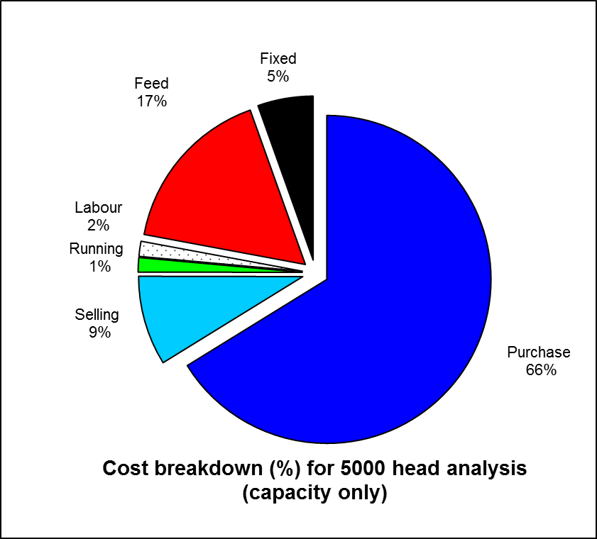
Figure 6: Percentage input cost breakdown for a 5000-head feedlot analysis finishing
to feedlot capacity (5000 lambs annually)

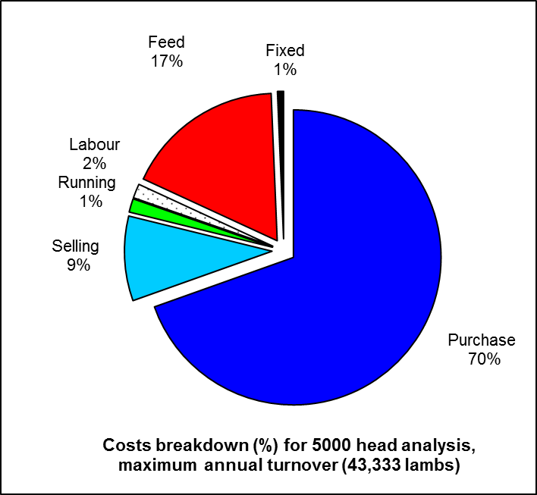

Figure 7: Percentage input cost breakdown for a 5000-head feedlot analysis finishing
to feedlot maximum annual throughput (43 333 lambs annually)
Fixed costs, defined as the 'capital cost' attributable to each lamb entering the feedlot over a 12-month period, range from ~1% of total input costs for maximum throughput systems up to 5% if finishing only to feedlot capacity annually. This equates to a $6.98 per lamb difference in these costs for the 5000/43 333 feedlot scenario.

This range in fixed costs has a major impact on system profitability. Maximizing lamb throughput regardless of feedlot operational size/capacity and/or establishment cost is therefore strongly recommended if choosing to finish lambs on a commercial scale within a feedlot.
Purchase Price (buy-in price, commissions, transport, yard due etc costs) is the on-farm landed cost of the Restocker/Feeder lamb. If finishing own-bred lambs, producers and/or feedlot operators should enter an equivalent ‘net sale’ value within the Sheep CRC Feedlot Calculator and not a Cost of Production (CoP) value.
In recent years purchase price has been the major input cost of any finishing system whether pasture or grain-fed based. Reduced breeding ewes/lamb numbers nationally and growing interest in finishing lambs have kept Store (eastern states) and Restocker/Feeder (WA) lamb values artificially high relative to finished lamb prices.

Purchase price continues to impact heavily on profitability with the percentage share of total input costs between 66 and 70% in the 5000/43 333 head scenarios shown above

Analysis of eastern state Store and Trade/Heavy lamb ‘relativities’ in recent years suggests that the price of the lamb (on entry) ‘relative’ to the finished lamb generally needs to be below parity to minimise risk and achieve reasonable profit margins. An example of how to calculate ‘relativity’ is shown on page 11.

Profitability of finishing lambs in large-scale feedlot (5000 to 50 000 head) systems

Once infrastructure/capital costs were calculated for each feedlot system standardized stock performance, treatments, variable costs, ration costs etc were used across all systems.
These input values are included in the Sheep CRC Feedlot Calculator Analysis Assumptions discussion on pages 17-18 of this report.
Feedlot system ‘Capacity’ (eg 5000, 10 000 head etc) and ‘Maximum Annual Throughput’ (eg 43 333 for a 5000-head feedlot based on lamb finishing time, deaths etc) totals were also analyzed to determine if a proportionate saving in costs, and ultimately a change in profit margins, may be gained by increasing production (economies of scale) within each system.
Sale values from January 2010 to May 2017 for a range of lamb weight categories reported within WA were collated and analyzed to provide:
- lamb category and mutton weekly, annual averages and ranges
- price differences between lamb categories /mutton within and between years
- annual variation in lamb/mutton values
- seasonal (summer/autumn/winter/spring) variation in lamb category values
- the ‘relativity’ score when comparing Restocker/Feeder prices to Trade and Heavy lamb prices 8 weeks later. This ‘relativity’ value can be used as an indicator of finished (i.e. Trade) lamb sale price targets when analyzing feedlotting profitability. An example of how the ‘relativity’ values were generated is shown below:

Figure 8: Example of Excel spreadsheet used to generate Restocker/Feeder versus Trade
lambs (8 weeks later) ‘relativity’ value

The averages values for Restocker/Feeder (16-18kg HSCW) and Trade (23kg HSCW) lamb categories for 2017 were $93.65 (551c/kg carcass weight including skin) and $133.40 (580c/kg) respectively.
These figures represented a ‘relativity’ value of 95% for Restocker/Feeder lamb compared to finished Trade lambs.
These values ($93.65, $133.40) were used as ‘base’ costs for each analysis.
Ration ‘base’ cost was $298 per tonne as fed. Rations consisted of 90% pellet/10% cereal/pasture hay. Pelleted rations were selected instead of grain/fibre mixes because:
- many large-scale operations favor pellet use
- pelleted diets are widely available in WA
- they are reasonably easy to manage
- they provide a balanced ration in terms of energy, protein, vitamins and minerals
- they minimize ration preparation time
- they do not require specialized equipment compared to grain/fibre ration preparation on-farm
- they provide producers the opportunity to reduce ration and transport costs if able to provide the pellet manufacturer with grain (raw product) and transport finished product (pellets) within a single delivery/collection cycle.

Base Restocker/Feeder, Trade lamb and ration costs were analyzed across the five large-scale feedlot systems before combinations of lower and higher costs for all three inputs were further analyzed as part of a sensitivity study.

Prices were either +/- 5 and/or 10% of the base cost values. Prices analyzed were as follows:

 | -5% | -10% | Base | +5% | +10%
Restocker/Feeder | $ 84.29 | $ 88.97 | $ 93.65 | $ 98.33 | $103.02
Trade lambs | $120.06 | $126.73 | $133.40 | $140.07 | $146.74
Ration | $268.00 | $283.00 | $298.00 | $313.00 | $328.00

A copy of the Sensitivity Analysis and Feedlot Profitability under a number of input price scenarios are shown in Appendix 6 and 7 respectively

In summary, the analysis showed:
- Feedlotting profitability based on input values analyzed and regardless of feedlot size or throughput is generally negative or low.
- The greatest influence on profit was the Restocker/Feeder lamb starting value relative to Trade lamb values.
- Profit margins from
  - 10c/head (0%/+10%/Base price for Restocker and Trade inputs values; 20 000 head run at capacity) to a maximum of
  - $14.80 (-5%/+10% Base price for Restocker and Trade inputs values; 50 000 head, maximum throughput annually)
were possible based on input values analyzed provided the Restocker/Feeder to Trade
lamb ‘relativity’ was 86% or lower.
- Ration cost had little impact on change in profit margin generated (Note: Initial analysis indicated that a 5 to 10% + or – change in ration cost had only minor impacts on profitability and generated data is not shown in this report).

Appendix 1 Scope of Works Overview

Background
The Sheep Industry Business Innovation project aims to develop technical and business information and facilitation of new sheep value chains within WA. The Investor-Ready Sheep Feedlot project seeks to determine establishment costs, infrastructure requirements, environmental impact and effluent management assessments and a benefit/cost feasibility study for a low input, large-scale (from 10 000 to 50 000 head) commercial sheepmeat feedlot.
This preliminary study will inform a larger report and analysis on the returns on investment (ROI) of a range of sized feedlots and locations within WA.
Objectives
- A desktop report on the infrastructure required, including water, power and effluent disposal and the indicative costs of construction for a commercial grade, low labour sheepmeat feedlot for 10 000, 20 000, 30 000 and 50 000 head.
- A desktop analysis on feedlot profitability for feedlots of 10 000, 20 000, 30 000 and 50 000 head with respect to feed prices and the purchase and turn off price for stock.

Key Stakeholders
Client | Department of Agriculture and Food Western Australia (DAFWA)
Project Supplier | Sheep Solutions
Project Manager | Geoff Duddy
Project Proposal
The information, statements, statistics and recommendations contained in the Final Report will be prepared by Sheep Solutions Principal Consultant Mr Geoff Duddy from publicly available material, discussions with stakeholders, data analysis and personal experience. Mr David Zinga (Zinga and Associates Pty Ltd) will be sub-contracted by Sheep Solutions to help prepare, develop and present findings of the Final Report relative to his areas of expertise as required.
Few states currently have in place specific, legislated standards for intensive sheepmeat feeding developments. The Report will, unless stated, base recommendations/findings on procedures and guidelines outlined in National procedures and guidelines for intensive sheep and lamb feeding systems (Dickson and Jolly, 2011). Where legislation requires a higher standard than recommendations within the document these standards will be applied.

Objective 1:
A desktop report on the infrastructure required, including water, power and effluent disposal and the indicative costs of construction for a commercial grade, low labour sheep meat feedlot for 10 000, 20 000, 30 000 and 50 000 head
The Report will outline development approval procedures/relevant planning authorities/ planning requirements/indicative costings and timeframe estimates. Development approvals are required to ensure all environmental and animal welfare standards are compatible with surrounding land use, its likely future use and community amenity.

Planning and management checklists will be included to assist producers to benchmark and assess their intensive feeding system against recommendations outlined within the National procedures and guidelines for intensive sheep and lamb feeding systems document.

The Report will include information required for a large-scale feedlot development application. Site information; description of subject land; locality plans; climatic information; intensive feeding system/soil and groundwater/solid and liquid waste/odour/dust/noise/pest control/animal welfare/composting, environmental information, site management and emergency management plans etc will be based on a ‘model’ farm. The ‘model’ farm descriptors will be outlined within the Report.

Although not included within the current Terms of Reference several
- Feed delivery (self-feeders, daily feed delivery bunk and automated bunk delivery)
- Feedlot designs (outdoor, outdoor/shedded and shedded) and
- Ration type (grain/hay; pelleted and Total Mix Ration)
systems will be discussed/analysed in terms of specific advantages/disadvantages; benefit/cost; capital expenditure; risk and efficiencies within the Report

We feel it important that these be considered as an additional component of the Investor Ready Feedlot Project.

The Report will provide:
- a comprehensive SWOT (Strengths, Weaknesses, Opportunities and Threats) analysis for variable scale feedlots and
- information/recommendations on:
  - market prospects for lamb and sheepmeat within WA
  - store/light/finished lamb and mutton price trends within WA
  - capital costs associated with establishing lamb feedlot modules - varying operational sizes
  - key design and management recommendations associated with operating a sheepmeat feedlot including stock class, start weight, weight gain targets, feed rations and feed quality, animal health issues, food safety and supply chain management etc
  - water quality and quantity requirements for sheep feedlot activities
  - ‘other’ as required.

Objective 2:
A desktop analysis on feedlot profitability for feedlots of 10 000, 20 000, 30 000 and 50 000 head with respect to feed prices and the purchase and turn off price for stock.
A comprehensive analysis of feedlot profitability/break-even prices and benefit/costs for each large-scale operation will be undertaken using the Sheep CRC Feedlot Calculator (developed by Project Manager Geoff Duddy) and, where necessary, additional software programs.
Project Management would also suggest analysis be undertaken to compare the feasibility of:
- smaller scale (5000-10 000 head) systems
- ‘satellite’ owner operated small scale operations … minimizing input freight costs, improving biosecurity, reducing health, disease and operational risk associated with larger scale operations
- producer alliances and/or a producer co-operative approach (members provide lambs and feed inputs to a central feeding site, cover associated management costs and receive a profit-share dividend when marketed).

Although 1) to 3) above are not included within the current Terms of Reference we feel it important that these also be included within the Report and will be undertaken if considered appropriate by DAFWA and if our project submission is successful.

The “Investor Ready Sheepmeat Feedlot Project” analysis/desktop study will be undertaken within time frames shown in Table 1.

Table 1: Timeframe
 | Description of Work | Start/Completion Dates
Phase One | Proposal submission | February 17th, 2017
Phase Two | Notification of Submission Acceptance | February 28th, 2017 ^{(a)}
Phase Three | Project Undertaken  - Objective 1 (report)  - Objective 2 (analysis) | February 28th – April 28^{th,} 2017 ^{(a)}
Phase Five | Final Project Report Submission (electronic) | April 28th, 2017 ^{(a)}
- Estimate only, dates dependent on submission acceptance

Appendix 2 Curriculum Vitae (Geoff Duddy)

Geoffrey Ross Duddy
0427007490
geoff@sheepsolutions.com.au
Lot 1 McNeil Rd Leeton NSW 2705, Australia

Principal Consultant – Sheep Solutions (June 2013 – Present)
Offering individual one on one through to Nationally Recognised Competency Based Training Workshops and project options. Multiskilled in all facets of sheep meat nutrition, production, management and marketing. An accredited Bred Well Fed Well, Ram Select, Lamb 2020, Lifetime Ewe, Prograze, Stockplan and Live Lamb Assessment deliverer.

District Livestock Officer (Sheep and Wool) Yanco, NSW (June 1990-June 2013)
Serviced client enquiries and facilitate producer/industry training and best practice management uptake
- Technical specialist within several fields nationally including intensive lambing management systems; prime lamb production and marketing; ‘new’ and introduced sheep breeds; irrigated pasture and grain-based lamb finishing systems (feedlots)
- Coordinated prime lamb production and marketing system development and protocols (including development of several prime lamb alliances),
- Involved in numerous national feedlotting forums, workshops and programs including MLA “Prime Time” Forums, Feedlot Industry Development workshops, Australian Lamb Finishers workshops, MLA Live Sheep Salmonellosis Project and development of Australian National Procedures and Guidelines for Intensive Sheep and Lamb Feeding Systems
- Author/co-author of numerous publications including
  - Producing and Marketing Lambs to Specification in NSW
  - New and Introduced Sheep Breeds in Australia (MLA)
  - Feedlotting Lambs (NSW DPI Primefact)
  - National Procedures and Guidelines for Intensive Sheep and Lamb Feeding Systems
  - International Sheep and Wool Handbook (ed D Cottle) – 2 chapters

Additional Training:
Certificate IV in Training and Assessment (TAE40104 and TAE 40110)
Certificate IV in Conservation and Land Management (RTD40102)
Handle Livestock using basic techniques (AHCLSK205A)
SmartTrain AQF3 Chemical Application
Train Small Groups; TopFodder; Excel; Client Service Training
AUS-MEAT ACFM – Ovine

Achievements/Accomplishments:
- Designed/developed Sheep CRC Lamb Feedlot Calculator
- Co-ordinated/managed numerous intra-departmental and industry based projects and evaluations
- Input into the development/revision of
  - National Animal Welfare,
  - Livestock Handling and
  - Live Lamb Assessment training manuals, competencies and training workshops/packages
- Responsible for NLRS Livestock Reporter professional development, delivering accreditation workshops for staff nationally since 2002.

Appendix 3 Curriculum Vitae (David Zinga)

Re : DAFWA Project

Zinga & Associates has been involved in many projects for over 20 years now and work closely with our clients in achieving sustainable environmental management outcomes.

We specialise in feedlot design, Environmental Impact Assessment, and environmental planning & management issues including environmental monitoring. We can assist in achieving environmental sustainability of effluent treatment and disposal systems and compliance with EPA licence requirements.

Please don’t hesitate to contact me re any of the above matters

David E. Zinga
15 February 2017
Mobile: 0407 41 77 41
Email: d.zinga@bigpond.com

Services and Project Listing
Zinga & Associates have a range of experience, over many years, in providing environmental management advice to abattoirs, as well as other intensive animal industries such as cattle and sheep feedlots, dairies, and piggeries.

Following are a list of services provided by Zinga & Associates and projects undertaken to date that are relevant to this proposal:
- Treatment Pond designs & Supervision of earthworks construction
- Stormwater Runoff & Drainage design
- Erosion & Sediment Control Planning
- On-going Environmental Monitoring – quarterly/six monthly
- Annual EPA reporting
- Effluent Irrigation Management
- Agronomic recommendations & soil management
- Liaison with Council and EPA re Development Consents
- Advice on EPA Licence issues
- Completion of Environmental Management Systems - ISO 9001
- National Pollution Inventory reporting
- Environment & Resource Efficiency Planning

SOILS INVESTIGATION (2016) – Abattoir, Clermont, QLD
ENVIRONMENTAL IMPACT STATEMENT (2016) – Beef Feedlot, Leeton
ENVIRONMENTAL PLANNING (2016) – Radfords Abattoir, Warragul
SOIL & WATER MANAGEMENT PLAN (2015) – Bindaree Beef, Inverell
ENVIRONMENTAL IMPACT STATEMENT (2015) – 5000 Beef & 15000 Sheep Feedlot, Conargo
ENVIRONMENTAL IMPACT STATEMENT (2014) – 5000 Cow Free Stall Dairy, Eastern Riverina
ENVIRONMENTAL IMPACT STATEMENT (2014) – 40000 Sheep Feedlot, Condobolin
DESIGNS & SITE INVESTIGATIONS (2013) - 5000 Beef Feedlot, Moree
ABATTOIR EXPANSION SUBMISSION EPA VIC. (2013) – Swan Hill Abattoir

ENVIRONMENTAL MANAGEMENT PLAN (2013) – AACo, Darwin Abattoir
EFFLUENT TREATMENT SYSTEM INVESTIGATIONS (2012) – AACo, Darwin Abattoir
ENVIRONMENTAL MANAGEMENT PLANNING (2011) – Young Abattoir
ANNUAL ENVIRONMENTAL MONITORING REPORT (2010) – 50000 Sheep Feedlot, Warren
ENVIRONMENTAL IMPACT STATEMENT (2010) – 7500 Head Beef Feedlot, Balranald
SITE INVESTIGATION (2010) – Proposed Camel Abattoir, Port Pirie, South Australia
SITE INVESTIGATION (2010) – Existing Abattoir, Esperance, Western Australia
DESIGN 50 ML WATER STORAGE DAM (2010) – Grenfell
FEASABILITY STUDY (2009) – 15000 Sheep Feedlot, Moulamein
ENVIRONMENTAL REPORT 3600 BEEF FEEDLOT (2009) - Deniliquin
LAMB FEEDLOT FEASABILITY (2009) - Canowindra
ENVIRONMENTAL MANAGEMENT REPORT (2009) - Gulgong Beef Feedlot
ANNUAL ENVIRONMENTAL MONITORING REPORT (2009) - Swan Hill Abattoirs
ENVIRONMENTAL MONITORING REPORT (2009) - 500 Sow Piggery Dunedoo
ENVT. & RESOURCE EFFICIENCY PROGRAM (2008) – Swan Hill Abattoirs
TRAINING EARTHMOVING CONTRACTORS - Lachlan R. Catchment Management Authority (2008)
STATEMENT OF ENVIRONMENTAL EFFECTS (2008) – Beef Feedlot, Boorowa
STATEMENT OF ENVIRONMENTAL EFFECTS (2008) – Beef Feedlot, Balranald
CHARLES STURT UNIVERSITY (2007 & 2008) – Lecturing Property & Catchment Planning
SITE INVESTIGATION (2007) – Waikerie Abattoir, South Aust.
DESIGN 99 ML EFFLUENT & IRRIGATION STORAGE DAM (2007) – Deniliquin

Appendix 4 -Sheep CRC Feedlot Calculator

Available from http://www.sheepcrc.org.au/resources/psm-software-feedlot-calculator.php

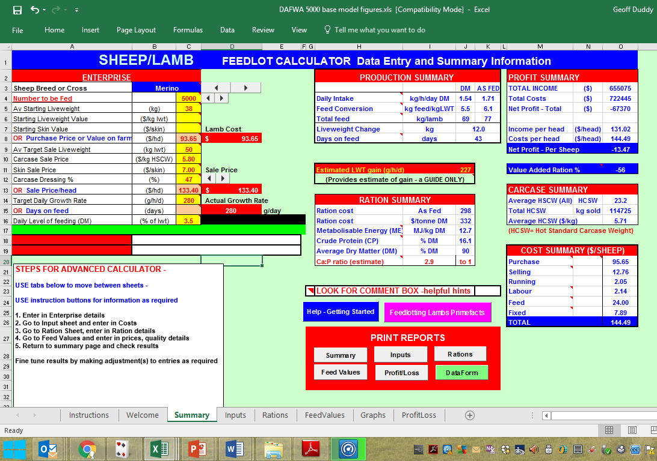

Appendix 5 Analysis Assumptions and costings
Pen Infrastructure assumptions and costs
Feedlot Capacity |  | 5000 | 10 000 | 20 000 | 30 000 | 50 000
Total lengths per pen (metres) | 180
Pen number needed |  | 10 | 20 | 40 | 60 | 100
Total pens (2 sick pens/5000 lambs) |  | 12 | 24 | 48 | 72 | 120
Pen dimensions (50*40m) | Total lengths (metres) | 2160 | 4320 | 8640 | 12960 | 21600
Cost/km | $7000 | $15,120 | $30,240 | $60,480 | $90,720 | $151,200
Cost/km 2.5% reduced per 5000 lambs | ($) | $15,120 | $29,484 | $57,456 | $83,916 | $132,300
Feedlot ‘capacity’ |  | 5000 | 10 000 | 20 000 | 30 000 | 50 000
Total lambs in feedlot/yr. |  | 43 333 | 86 667 | 173 333 | 260 000 | 433 333
Cost based on feedlot capacity |  | $3.02 | $2.95 | $2.87 | $2.80 | $2.65
Cost/annual lambs - 1 year |  | $0.35 | $0.34 | $0.33 | $0.32 | $0.31
Cost/annual lambs - 5 years |  | $0.07 | $0.07 | $0.07 | $0.06 | $0.06
Cost/annual lambs - 10 years |  | $0.03 | $0.03 | $0.03 | $0.03 | $0.03
Cost/annual lambs - 15 years |  | $0.02 | $0.02 | $0.02 | $0.02 | $0.02
Water delivery assumptions and costs
Feedlot Capacity |  | 5000 | 10 000 | 20 000 | 30 000 | 50 000
5*110,000 L supply tanks per 5000 for 3-day supply | 45000 (litres)
Supply line from source - 2km total | 3200 (metres)
Trough cost (4.3m concrete with float) | $600
Poly and fittings per pen | $327
Cost per pen (share of tanks cost, trough, pipe, fittings, labour etc) |  | $4,944 | $2,935 | $1,931 | $1,596 | $1,329
Cost per pen (no tank cost) |  | $1,194 | $1,060 | $994 | $971 | $954
Cost per pen (share of tanks cost, trough, pipe, fittings, labour etc) 2.5% reduced per 5000 lambs |  | $4,944 | $2,862 | $1,835 | $1,477 | $1,163
Cost per pen (no tank costs) 2.5% reduced per 5000 lambs |  | $1,194 | $1,034 | $944 | $899 | $834
Pen number needed |  | 10 | 20 | 40 | 60 | 100
Total pens (2 sick pens/5000 lambs) |  | 12 | 24 | 48 | 72 | 120
Total cost |  | $59,324 | $68,687 | $88,061 | $106,323 | $139,510
Total cost not including water tanks |  | $14,324 | $24,812 | $45,311 | $64,698 | $100,135
Feedlot ‘capacity’ |  | 5000 | 10 000 | 20 000 | 30 000 | 50 000
Total lambs in feedlot/yr. |  | 43 333 | 86 667 | 173 333 | 260 000 | 433 333
Cost based on feedlot capacity |  | $11.86 | $6.87 | $4.40 | $3.54 | $2.79
Cost/annual lambs - 1 year |  | $1.37 | $0.79 | $0.51 | $0.41 | $0.32
Cost/annual lambs - 5 years |  | $0.27 | $0.16 | $0.10 | $0.08 | $0.06
Cost/annual lambs - 10 years |  | $0.14 | $0.08 | $0.05 | $0.04 | $0.03
Cost/annual lambs - 15 years |  | $0.09 | $0.05 | $0.03 | $0.03 | $0.02
Feedlot capacity - daily intake (av over year) | 4.3 | 21 500 | 43 000 | 86 000 | 129 000 | 215 000
Total lambs in feedlot/yr. - daily intake | Number | 186 333 | 372 667 | 745 333 | 1 118 000 | 1 863 333
Feedlot capacity - annual | 365 | 7 847 500 | 15 695 000 | 31 390 000 | 47 085 000 | 78 475 000
Total lambs in feedlot/yr. - annual | Litres | 68 011 667 | 136 023 333 | 272 046 667 | 408 070 000 | 680 116 667
Total lambs in feedlot/yr. - annual Megalitres | ML | 68 | 136 | 272 | 408 | 680

Total Establishment Costs |  | $59,324 | $68,687 | $88,061 | $106,323 | $139,510
Total Establishment Costs (no tanks) |  | $14,324 | $24,812 | $45,311 | $64,698 | $100,135
Stock Number assumptions
 |  | In Feedlot
 |  | 5000 | 10 000 | 20 000 | 30 000 | 50 000
Deaths | 1% | 50 | 100 | 200 | 300 | 500
Shy feeders | 5% | 250 | 500 | 1000 | 1500 | 2500
Total sold | (lambs) | 4950 | 9900 | 19 800 | 29 700 | 49 500
No. per week sold | (lambs) | 825 | 1650 | 3300 | 4950 | 8250
No. per week bought | (lambs) | 833 | 1667 | 3333 | 5000 | 8333
No. per year in total | (lambs) | 43333 | 86 667 | 173 333 | 260 000 | 433 333
Feeder Assumptions
 |  | 5000 | 10 000 | 20 000 | 30 000 | 50 000
Trough length needed (cm/head) | 5 cm | 25 000 | 50 000 | 100 000 | 150 000 | 250 000
Number of 4.8m modified feeder feed face (single side feed) needed | 4800 cm/feeder | 52 | 104 | 208 | 313 | 521
Total feeder cost ($2200/feeder) |  | $114,583 | $229,167 | $458,333 | $687,500 | $1,145,833
Total feed face | cm | 25 000 | 50 000 | 100 000 | 150 000 | 250 000
Pen number needed |  | 10 | 20 | 40 | 60 | 100
Total pens (2 sick pens/5000 lambs) |  | 12 | 24 | 48 | 72 | 120
Modified 4.8m feed face feeders per pen |  | 5 | 5 | 5 | 5 | 5
Total feeder holding capacity (kg) | 2400kg | 125 000 | 250 000 | 500 000 | 750 000 | 1 250 000
Total kg eaten per day (av) | 1.71kg | 8550 | 17 100 | 34 200 | 51 300 | 85 500
Feed days from total pen feeder length |  | 15 | 15 | 15 | 15 | 15
Cost comparison feeder’s vs daily bunk feeding |  | Labour cost per day
If feeders, 5c/hd/day labour | $0.05 | $250 | $500 | $1,000 | $1,500 | $2,500
If bunk, 10c/hd/day one feed | $0.10 | $500 | $1,000 | $2,000 | $3,000 | $5,000
If bunk, 15c/hd/day two feeds | $0.15 | $750 | $1,500 | $3,000 | $4,500 | $7,500
Feeder' labour saving/day compared to once day bunk feeding | 1 day | $250 | $500 | $1,000 | $1,500 | $2,500
Feeder' labour saving/yr. compared to once day bunk feeding | 365 days | $91,250 | $182,500 | $365,000 | $547,500 | $912,500
Feeder' labour saving per total lambs sold annually |  | $2.11 | $2.11 | $2.11 | $2.11 | $2.11
Feeder' labour saving/day compared to twice day bunk feeding | 1 day | $500 | $1,000 | $2,000 | $3,000 | $5,000
Feeder' labour saving/yr. compared to twice day bunk feeding | 365 days | $182,500 | $365,000 | $730,000 | $1,095,000 | $1,825,000
Feeder' labour saving per total lambs sold annually |  | $4.21 | $4.21 | $4.21 | $4.21 | $4.21
Cost per lamb feeder (4.8m length) | $2,200 | $114,583 | $223,438 | $435,417 | $635,938 | $973,958
Cost per lamb bunk (4.8m length) | $500 | $26,042 | $50,781 | $98,958 | $144,531 | $221,354
Difference |  | $88,542 | $172,656 | $336,458 | $491,406 | $752,604
Feeder' labour saving/yr. compared to once day bunk feeding | 365 | $91,250 | $182,500 | $365,000 | $547,500 | $912,500
Difference advantage to feeders | ($) | 2,708 | 9,844 | 28,542 | 56,094 | 159,896
Advantage to feeders - 1 year | ($) | 2,708 | 9,844 | 28,542 | 56,094 | 159,896
Advantage to feeders - 5 years | ($) | 13,542 | 49,219 | 142,708 | 280,469 | 799,479
Advantage to feeders - 10 years | ($) | 27,083 | 98,438 | 285,417 | 560,938 | 1,598,958
Advantage to feeders - 15 years | ($) | 40,625 | 147,656 | 428,125 | 841,406 | 2,398,438
Difference over 15 years’ life | ($) | 5,903 | 11,510 | 22,431 | 32,760 | 50,174
Difference over 15 years’ life per metre | ($) | 1,229.7 | 2,398.0 | 4,673.0 | 6,825.1 | 10,452.8
Difference per year over 15 years’ life per metre | ($) | 82.0 | 159.9 | 311.5 | 455.0 | 696.9
Time for feeder to pay off difference in est costs when include labour saving compared once day bunk feeding |  | 0.97 | 0.95 | 0.92 | 0.90 | 0.82
 | days | 354 | 345 | 336 | 328 | 301
 | months | 11.4 | 11.1 | 10.9 | 10.6 | 9.7
 | years | 0.95 | 0.93 | 0.90 | 0.88 | 0.81
Feeder' saving/yr. compared to twice day bunk feeding | 365 | 182,500 | 365,000 | 730,000 | 1,095,000 | 1,825,000
Difference advantage to feeders | ($) | 93,958 | 192,344 | 393,542 | 603,594 | 1,072,396
Advantage to feeders - 1 year | ($) | 93,958 | 192,344 | 393,542 | 603,594 | 1,072,396
Advantage to feeders - 5 years | ($) | 469,792 | 961,719 | 1,967,708 | 3,017,969 | 5,361,979
Advantage to feeders - 10 years | ($) | 939,583 | 1,923,438 | 3,935,417 | 6,035,938 | 10,723,958
Advantage to feeders - 15 years | ($) | 1,409,375 | 2,885,156 | 5,903,125 | 9,053,906 | 16,085,938
Difference over 15 years’ life | ($) | 5,903 | 11,510 | 22,431 | 32,760 | 50,174
Difference over 15 years’ life per metre | ($) | 1,229.7 | 2,398.0 | 4,673.0 | 6,825.1 | 10,452.8
Difference per year over 15 years’ life per metre | ($) | 82.0 | 159.9 | 311.5 | 455.0 | 696.9
Time for feeder to pay off difference in est costs when include labour saving compared twice day bunk feeding |  | 0.49 | 0.47 | 0.46 | 0.45 | 0.41
 | days | 177 | 173 | 168 | 164 | 151
 | months | 5.7 | 5.6 | 5.4 | 5.3 | 4.9
 | years | 0.48 | 0.46 | 0.45 | 0.44 | 0.40
Cost per lamb in feedlot | ($) | $17 | $16 | $16 | $15 | $14
Feedlot capacity | ($) | 5000 | 10 000 | 20 000 | 30 000 | 50 000
Total lambs in feedlot/yr. | ($) | 43 333 | 86 667 | 173 333 | 260 000 | 433 333
Cost based on feedlot capacity | ($) | $16.50 | $16.09 | $15.68 | $15.26 | $14.44
Cost/annual lambs - 1 year | ($) | $1.90 | $1.86 | $1.81 | $1.76 | $1.67
Cost/annual lambs - 5 years | ($) | $0.38 | $0.37 | $0.36 | $0.35 | $0.33
Cost/annual lambs - 10 years | ($) | $0.19 | $0.19 | $0.18 | $0.18 | $0.17
Cost/annual lambs - 15 years | ($) | $0.13 | $0.12 | $0.12 | $0.12 | $0.11
Shade/Shelter Infrastructure
 |  | 5000 | 10 000 | 20 000 | 30 000 | 50 000
500 lambs/pen
Total Eco shelter number |  | 10 | 20 | 40 | 60 | 100
Cost ($10,000 each) |  | $100,000 | $200,000 | $400,000 | $600,000 | $1,000,000
Cost (2.5% reduced/5000) |  | $100,000 | $195,000 | $380,000 | $555,000 | $875,000
Cost/lamb (reduced 2.5%/5000) |  | $20.00 | $19.50 | $19.00 | $18.50 | $17.50
Total lambs in feedlot/yr. |  | 43 333 | 86 667 | 173 333 | 260 000 | 433 333
Cost/lamb annual | 1 year | $2.31 | $2.31 | $2.31 | $2.31 | $2.31
 | 5 years | $0.46 | $0.45 | $0.44 | $0.43 | $0.40
 | 10 years | $0.23 | $0.23 | $0.22 | $0.21 | $0.20
 | 15 years | $0.15 | $0.15 | $0.15 | $0.14 | $0.13
Land forming
 |  | 5000 | 10 000 | 20 000 | 30 000 | 50 000
Total area (m²) per module | 35000m² | 35 000 | 70 000 | 140 000 | 210 000 | 350 000
Cost/hour (GST incl) | $250/hour
Estimated hours per module | 35
Total Cost based on feedlot capacity | ($) | $8,750 | $17,500 | $35,000 | $52,500 | $87,500
Total lambs in feedlot/yr. |  | 43333 | 86 667 | 173 333 | 260000 | 433333
Cost based on feedlot capacity (lambs/cost) | ($) | $1.75 | $1.75 | $1.75 | $1.75 | $1.75
Cost (2.5% reduction/5000) | ($) | $8,750 | $17,063 | $33,250 | $48,563 | $76,563
Cost/annual lambs - 1 year | ($) | $8,750 | $17,063 | $33,250 | $48,563 | $76,563
Cost/annual lambs - 5 years | ($) | $1,750 | $3,413 | $6,650 | $9,713 | $15,313
Cost/annual lambs - 10 years | ($) | $875 | $1,706 | $3,325 | $4,856 | $7,656
Cost/annual lambs - 15 years | ($) | $117 | $228 | $443 | $648 | $1,021
Feeder face concrete apron costings
 |  | 5000 | 10 000 | 20 000 | 30 000 | 50 000
Pens |  | 10 | 20 | 40 | 60 | 100
Total concrete (metres) | (m²) | 750 | 1500 | 3000 | 4500 | 7500
$110/m² |  | $82,500 | $165,000 | $330,000 | $495,000 | $825,000
$110 (2.5% reduction/5000) |  | $82,500 | $160,875 | $313,500 | $457,875 | $721,875
Feedlot capacity |  | 5000 | 10 000 | 20 000 | 30 000 | 50 000
Total lambs in feedlot/yr. |  | 43 333 | 86 667 | 173 333 | 260 000 | 433 333
Cost based on feedlot capacity | ($) | $16.50 | $16.09 | $15.68 | $15.26 | $14.44
Cost/annual lambs - 1 year | ($) | $1.90 | $1.86 | $1.81 | $1.76 | $1.67
Cost/annual lambs - 5 years | ($) | $0.38 | $0.37 | $0.36 | $0.35 | $0.33
Cost/annual lambs - 10 years | ($) | $0.19 | $0.19 | $0.18 | $0.18 | $0.17
Cost/annual lambs - 15 years | ($) | $0.13 | $0.12 | $0.12 | $0.12 | $0.11
Total Establishment Costs |  | $297,777.33 | $533,670.80 | $994,183.87 | $1,429,739.20 | $2,197,330.83
Total Establishment Costs not including water tanks |  | $252,777.33 | $489,795.80 | $951,433.87 | $1,388,114.20 | $2,157,955.83
Summary of Costs
 | Capacity | 5000 | 10 000 | 20 000 | 30 000 | 50 000
 | Annually | 43 333 | 86 667 | 173 333 | 260 000 | 433 333
Water Infrastructure
Total cost not including water tanks | ($) | 14,324 | 24,812 | 45,311 | 64,698 | 100,135
Pen Infrastructure | ($) | 15,120 | 29,484 | 57,456 | 83,916 | 132,300
Shade and Shelter | ($) | 100,000 | 195,000 | 380,000 | 555,000 | 875,000
Land forming | ($) | 8,750 | 17,063 | 33,250 | 48,563 | 76,563
Feeders | ($) | 114,583 | 223,438 | 435,417 | 635,938 | 973,958
Concrete | ($) | 82,500 | 160,875 | 313,500 | 457,875 | 721,875
Totals |  | 335,277 | 650,671 | 1,264,934 | 1,845,989 | 2,879,831
 | per capacity | $67.1 | $65.1 | $63.2 | $61.5 | $57.6
 | per annual | $7.7 | $7.5 | $7.3 | $7.1 | $6.6

Appendix 6 Sensitivity Analysis investigating the change in profitability of five feedlot systems
varying size and throughput
Analysis looks at the impact of a +/- 5 and 10% change in Restocker/Feeder lamb ($93.65); Trade lamb ($133.40) and Ration ($298 as fed) ‘base’ costs. Figures in blue denote positive profit. Those in red indicate the degree of loss compared to selling the Restocker /Feeder. Cells shaded in yellow indicate the Restocker/Feeder to Trade ‘relativity’ at which profit margins were recorded.

 |  |  |  | Lambs Finished Per Year
Restocker/ Feeder | Trade | Relativity' | Ration | 5000 | 43 333 | 10 000 | 86 667 | 20 000 | 173 333 | 30 000 | 260 000 | 50 000 | 433 333
 |  |  |  | Capacity | Annual Max | Capacity | Annual Max | Capacity | Annual Max | Capacity | Annual Max | Capacity | Annual Max
93.65 | 120.06 | 1.06 | 298.00 | -$25.32 | -$18.35 | -$24.14 | -$17.97 | -$23.60 | -$17.91 | -$22.97 | -$17.84 | -$22.78 | -$17.81
93.65 | 126.73 | 1.00 | 298.00 | -$19.38 | -$12.41 | -$18.21 | -$12.04 | -$17.68 | -$11.98 | -$17.05 | -$11.91 | -$16.86 | -$11.89
93.65 | 133.40 | 0.95 | 298.00 | -$13.47 | -$6.50 | -$12.29 | -$6.12 | -$11.75 | -$6.06 | -$11.12 | -$5.98 | -$10.93 | -$5.96
93.65 | 140.07 | 0.90 | 298.00 | -$7.55 | -$0.57 | -$6.36 | -$0.19 | -$5.83 | -$0.13 | -$5.20 | -$0.06 | -$5.00 | -$0.04
93.65 | 146.74 | 0.86 | 298.00 | -$1.62 | $5.35 | -$0.44 | $5.73 | $0.10 | $5.79 | $0.73 | $5.87 | $0.92 | $5.89
84.29 | 133.40 | 0.85 | 298.00 | -$4.53 | $2.44 | -$3.38 | $2.79 | -$2.84 | $2.86 | -$2.21 | $2.93 | -$2.02 | $2.95
88.97 | 133.40 | 0.90 | 298.00 | -$9.00 | -$2.03 | -$7.83 | -$1.66 | -$7.30 | -$1.60 | -$6.67 | -$1.56 | -$4.57 | $0.40
93.65 | 133.40 | 0.95 | 298.00 | -$13.47 | -$6.50 | -$12.29 | -$6.12 | -$11.75 | -$6.06 | -$11.12 | -$5.96 | -$10.93 | -$5.96
98.33 | 133.40 | 1.00 | 298.00 | -$17.94 | -$10.97 | -$16.74 | -$10.57 | -$16.21 | -$10.51 | -$15.58 | -$10.44 | -$15.39 | -$10.43
93.65 | 133.40 | 0.95 | 268.00 | -$11.18 | -$4.21 | -$9.99 | -$3.83 | -$9.46 | -$3.76 | -$8.83 | -$3.69 | -$8.46 | -$3.67
93.65 | 133.40 | 0.95 | 283.00 | -$12.29 | -$5.32 | -$11.11 | -$4.94 | -$10.57 | -$4.88 | -$9.94 | -$4.80 | -$9.75 | -$4.78
93.65 | 133.40 | 0.95 | 298.00 | -$13.47 | -$6.50 | -$12.29 | -$6.12 | -$11.75 | -$6.06 | -$11.13 | -$5.98 | -$10.93 | -$5.96
93.65 | 133.40 | 0.95 | 313.00 | -$14.65 | -$7.68 | -$13.54 | -$7.37 | -$13.00 | -$7.31 | -$12.37 | -$7.23 | -$12.18 | -$7.21
93.65 | 133.40 | 0.95 | 328.00 | -$15.77 | -$8.79 | -$14.58 | -$8.41 | -$14.04 | -$8.35 | -$13.41 | -$8.28 | -$13.22 | -$8.25
84.29 | 120.06 | 0.95 | 298.00 | -$16.38 | -$9.41 | -$15.23 | -$9.06 | -$14.69 | -$8.99 | -$14.06 | -$8.92 | -$13.87 | -$8.90
84.29 | 133.40 | 0.85 | 298.00 | -$4.53 | $2.44 | -$3.38 | $2.79 | -$2.84 | $2.86 | -$2.21 | $2.93 | -$2.02 | $2.95
84.29 | 146.74 | 0.78 | 298.00 | $7.32 | $14.29 | $8.47 | $14.64 | $9.01 | $14.71 | $9.64 | $14.78 | $9.83 | $14.80
93.65 | 120.06 | 1.06 | 298.00 | -$25.32 | -$18.35 | -$24.14 | -$17.47 | -$23.60 | -$17.91 | -$22.97 | -$17.83 | -$22.78 | -$17.81
93.65 | 133.40 | 0.95 | 298.00 | -$13.47 | -$6.50 | -$12.29 | -$6.12 | -$11.75 | -$6.06 | -$11.12 | -$5.98 | -$10.93 | -$5.96
93.65 | 146.74 | 0.86 | 298.00 | -$1.62 | $5.35 | -$0.44 | $5.75 | $0.10 | $5.79 | $0.73 | $5.87 | $0.92 | $5.89
103.20 | 120.06 | 1.16 | 298.00 | -$34.44 | -$27.47 | -$33.23 | -$27.06 | -$32.69 | -$27.00 | -$32.07 | -$26.43 | -$31.88 | -$26.90
103.20 | 133.40 | 1.05 | 298.00 | -$25.59 | -$15.62 | -$21.38 | -$15.21 | -$20.84 | -$15.15 | -$20.22 | -$15.08 | -$20.03 | -$15.05
103.20 | 146.74 | 0.95 | 298.00 | -$10.74 | -$3.77 | -$9.63 | -$3.36 | -$8.99 | -$3.30 | -$8.37 | -$3.33 | -$8.18 | -$3.20

Appendix 7 WA feedlot profitability under three Restocker/Feeder and Trade lamb category price scenarios

Five (5) feedlot systems varying in size from 5000 to 50 000 capacity and their maximum annual throughputs (from 43 333 to 433 333) were analysed using ‘base’ starting values for Restocker/Feeder lamb ($93.65) and Trade lamb ($133.40). The impact on profit for a +/- change of 10% on starting ‘base’ values are shown in Figure 9 below.

The three scenarios analysed were:
Restocker/Feeder Trade Lamb
- RF (-10%)/Tr (+10%) -10% ($84.29) +10% ($146.74)
- RF (0)/Tr (+10) (0%) $93.65 (0%) $133.40
- RF (+10)/Tr (-10) +10% ($98.33) -10% ($126.73)
Ration ($298 as fed) costs were kept constant across all three scenarios.

Figure 9: WA feedlotting profitability under three (3) Restocker/Feeder and Trade lamb category price scenarios

WA feedlot profitability under eight Restocker/Feeder and Trade lamb category price scenarios

Five (5) feedlot systems varying in size from 5000 to 50 000 Capacity (Figure 10) and with maximum annual throughputs from 43 333 to 433 333 (Figure 11) were analysed.

‘Base’ starting values for Restocker/Feeder lamb ($93.65) and Trade lamb ($133.40) were used and the impact on profit for a +/- change of 5 to 10% on these values was investigated.

Coding for the % change analysed for Figures 10 and 11 were:

Restocker/Feeder Trade Lamb
- RF (-10%)/Tr (+5%) -10% ($84.29) + 5% ($140.07)
- RF (-10%)/Tr (+10%) -10% ($84.29) +10% ($146.74)
- RF (-5%)/Tr (+5%) - 5% ($88.97) + 5% ($140.07)
- RF (-5%)/Tr (+10%) - 5% ($88.97) +10% ($146.74)
- RF (0)/Tr (+10) 0% ($93.65) +10% ($146.74)
- RF (+10)/Tr (-10) +10% ($98.33) -10% ($126.73)
- RF (+10)/Tr (0) +10% ($98.33) 0% ($133.40)
- RF (+10)/Tr (+10) +10% ($98.33) +10% ($146.74)

Ration ($298 as fed) costs were kept constant across all 8 scenarios

Figure 10: WA feedlot profitability (feedlot capacity) and Restocker/Feeder and Trade lamb category price (+/- 5 and
10%) scenarios

Figure 11: WA feedlot profitability (annual maximum throughput) and Restocker/Feeder and Trade lamb category price (+/- 5 and 10%) scenarios

Appendix 8 Feedlot pen and proposed 5000 head Feedlot ‘module’ design

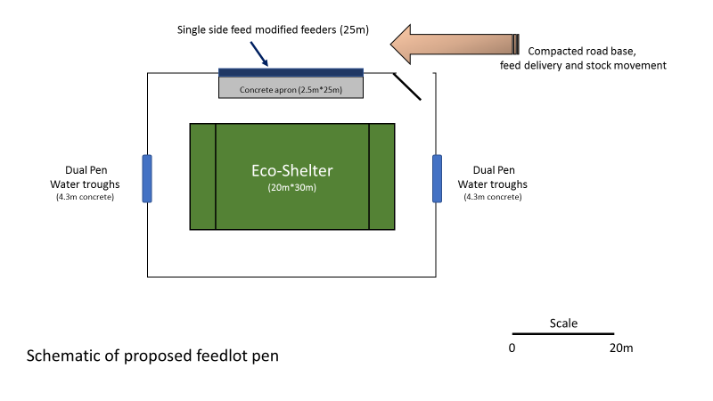

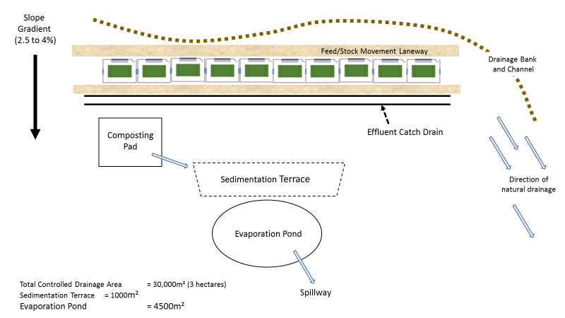

References:
- Anon (2017) Feedlot Technology Adoption Group Information for the Australian Beef Cattle Industry http://www.feedlottechnology.com/
- Anon (undated) Australian Animal Welfare Standards and Guidelines Standards for Sheep. Edition One Version One January 2016 http://www.animalwelfarestandards.net.au/files/2016/01/Sheep-Standards-and-Guidelines-for-Endorsed-Jan-2016-250116.pdf
- Anon (undated) Great Southern regional water supply strategy - A long-term outlook of water demand and supply Report no. 2 | December 2014 Regional water supply strategy series https://www.water.wa.gov.au/__data/assets/pdf_file/0005/2939/108261.pdf
- Anon (undated) Katanning Shire – Sheep Saleyards file:///C:/Users/Geoff/Desktop/Invoices/Projects%20-%20Other/DAFWA/Sheep%20Saleyards%20%C2%BB%20Shire%20of%20Katanning.html
- Anon (undated) Polytex Tarpaulins – Livestock Shade Sails file:///C:/Users/Geoff/Desktop/Invoices/Projects%20-%20Other/DAFWA/Eco%20Shelters%20Livestock%20Shade%20Sails%20_%20Polytex.html
- Anon (undated) Redpath Australia – Eco-shelters Animal Shelters http://www.redpath.com.au/commercial-structures/animal-ecoshelters.html
Anon (undated) Soil groups of Western Australia: a simple guide to the main soils of Western Australia (4th ed) http://researchlibrary.agric.wa.gov.au/rmtr/348/
- ATO (2016) Guide to depreciating assets 2016 https://www.ato.gov.au/uploadedFiles/Content/MEI/downloads/Guide-to-depreciating-assets-2016.pdf
- Bureau of Meteorology: Climate Statistics for Australian Locations http://www.bom.gov.au/climate/averages/tables/cw_010916_All.shtml
- Dickson, H and Jolly, S (2011) National procedures and guidelines for intensive sheep and lamb feeding systems Planning and management checklists: a review tool for producers https://static1.squarespace.com/static/5371735ee4b0edb14ea92086/t/538fa45be4b056260cc42af5/1401922651842/National+procedures+and+guidelines+lamb+finishing+-+checklists.pdf
- Dickson, H and Jolly, S (2011) National procedures and guidelines for intensive sheep and lamb feeding systems http://productivenutrition.com.au/index.php/Table/Independent-Livestock-Nutrition-and-Business-Management-Advice-to-Producers-and-Industry-across-Australia/
- Duddy, G; Shands, C; Bell, A; Hegarty, R and Casburn,G (2016) Feedlotting Lambs July 2016, Primefact 523, 2nd edition http://www.dpi.nsw.gov.au/__data/assets/pdf_file/0020/193313/Feedlotting-lambs.pdf
- Environmental Protection Authority Western Australia DRAFT Environmental Assessment Guideline for Separation distances between industrial and sensitive land uses https://consultation.epa.wa.gov.au/policy-and-guideline-development-and-review/draft-separation-distances-eag/supporting_documents/DRAFT%20EAG%20X%20Separation%20buffers%20September%202015.pdf
- Gazey,C and Andrew J (2009) Bulletin 4761 January 2009 ISSN 1833-7236 Soil pH in northern and southern areas of the WA wheatbelt file:///C:/Users/Geoff/Desktop/Invoices/Projects%20-%20Other/DAFWA/North_and_south_pH_report_151208.pdf
- JC Solutions (2014) Feed Grain Partnership Australian Feed Grain Supply and Demand Report 2013/14https://www.aecl.org/assets/www.aecl.org/outputs/140730-FGP-Supply and-Demand-Report-July-2014.pdf
- Pederick Engineering (WA) http://www.pederickengineering.com.au/index.php
- Stoneman, TC (1991) An introduction to the soils of the Katanning advisory district http://researchlibrary.agric.wa.gov.au/cgi/viewcontent.cgi?article=1023&context=bulletins
- Universal Feeders (WA) http://www.universalfeeders.com.au/about-us
- Young, J (2016) Seasonality of Lamb Supply – Have We Interpreted the Price Signals? https://www.agric.wa.gov.au/.../Seasonality%20of%20Lamb%20Supply%20John%20...

