Operation of the Grains, Seeds and Hay Industry Funding Scheme and Management Committee:

Results from a survey of grain/seed/hay growers

February 2018

# Executive summary

A survey of Western Australian grain/seed/hay growers was undertaken to ascertain industry views on the operation of the Grains, Seeds and Hay Industry Funding Scheme (IFS) and its Management Committee. A total of 180 responses were received from growers across the agricultural area.

The majority of respondents (77%) felt that the Western Australian grain/seed/hay industry needed an industry scheme to address pests and diseases. However, the responses regarding the current direction of the scheme were mixed — approximately half felt that three-horned bedstraw was a priority issue to be targeted by the scheme, whilst about 70% felt that skeleton weed was a priority issue for the scheme. Approximately 20% of respondents did not think skeleton weed or bedstraw were priority issues.

The majority of respondents (68%) did not believe that, at this point in time, there were other pests/diseases that should be addressed by the scheme. Of the pests/diseases that were identified for potential inclusion in the scheme, most were species that are not eligible for IFS-funding.

The majority (62%) of respondents believed that the IFS is capably managed by the Management Committee. Approximately one half believed that the IFS annual reports provide sufficient information on the operation of the scheme and that the level of industry engagement was appropriate.

The survey results suggest:

* Industry sees value in having a scheme for the grains/seeds/hay industry.
* Most of the industry view skeleton weed as a priority to be addressed via the scheme.
* There is uncertainty of the priority of three-horned bedstraw as a biosecurity risk to the industry.
* A relatively large number of growers do not think the scheme is addressing the industry’s priority biosecurity issues (approximately one-fifth of survey respondents).
* Industry understanding of the purpose and operation of the scheme is questionable — evidenced by respondents not knowing if they were scheme participants, the types of pests/diseases respondents felt that the scheme should target, specific comments made by respondents regarding the level of industry understanding, and the number of ‘unsure’ responses to questions.
* Annual reporting needs to be reviewed to ensure sufficient information on the operation of the scheme and promotion of the reports to industry.
* The level of industry engagement in the scheme requires review to identify the appropriate engagement level.

# Background

The Grains, Seeds and Hay Industry Funding Scheme (IFS) enables industry to raise funds to address priority pests and diseases at a whole-of-industry level. Contributions from the industry are collected on the sale of produce — 25 cents per tonne of grain/seed, and 12.5 cents per tonne of hay.

The Scheme is overseen by an industry-based Industry Management Committee (IMC). An important part of the IMC’s role is to consult with scheme contributors to ‘ascertain views of the grains, seeds and hay industry concerning the operation of the Scheme and the performance by the IMC’.

Accordingly, the purpose of the survey was to ascertain industry views on the operation of the IFS and IMC.

# Method

A simple questionnaire was used (Appendix 1). The questionnaire was presented in four parts: 1) value of the IFS; 2) operation of the IFS; 3) performance of the IMC; and 4) demographics. The survey was open for nine weeks (July – September 2017), and was able to be completed online, in hardcopy format or verbally over the telephone.

The survey was promoted through advertisements in the rural press, radio interviews and print articles. Information about the survey was also emailed to industry organisations/ groups, community groups and others. Feedback indicates that this email campaign resulted in the effective promotion of the survey to a large number of growers.

The data were screened, then analysed using simple frequencies and cross-tabulations.

# Results

A total of 180 responses were received. The optimal sample size for a survey (i.e. number of respondents) varies depending on the statistical formulae used for analyses and the types of questions being asked in the survey. For this simple survey, 94 responses (from a population of 5000) will provide a ±10% margin of error.

## Demographics

Responses were received from grain/seed/hay producers from across the agricultural area of Western Australia (Figure 1); however, seventy-one percent of the responses were received from growers whose main property was located in the central agricultural region.

The majority (67%) of respondents were over 45 years of age. The distribution of the age of respondents is comparable to that for Australian farmers; although the IFS survey attracted responses from a larger proportion of 35-44 year olds and fewer people aged over 65 years (see Appendix 2).

Seventy-six percent of the respondents were scheme participants; 4% had opted out; and 20% were unsure if they had opted out. It can be assumed that those that were ‘unsure’ were actually scheme participants, as it is expected that they would know if they had filled out the required paperwork to opt out.

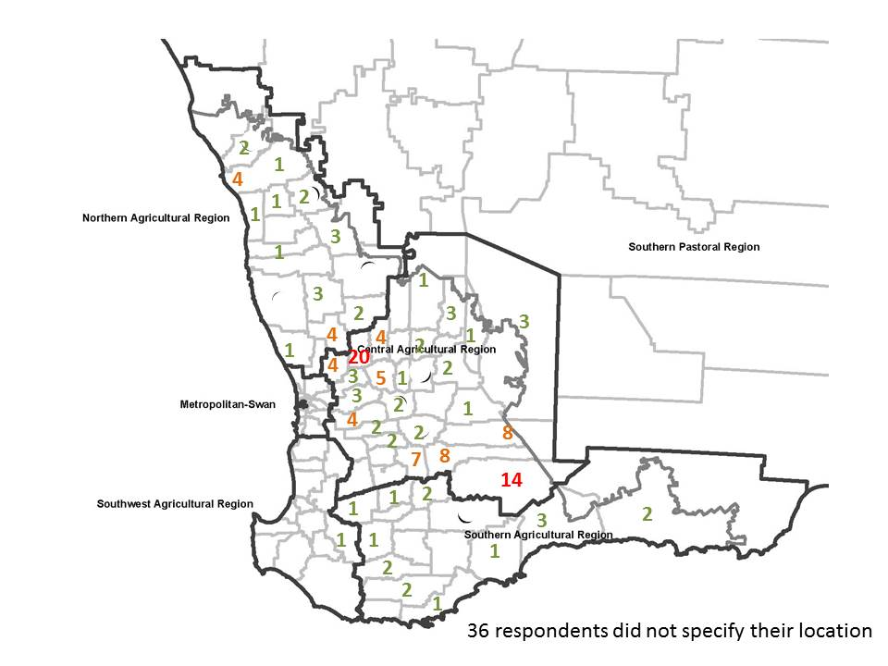

Figure 1. Number of responses to the grower survey, by Shire.

Note: 36 respondents did not specify their location.

## Need for an Industry Funding Scheme

The majority of respondents (77%) agreed that the Western Australian grain/seed/hay industry needs a scheme to address pests and diseases. Fifteen percent of respondents did not believe that a scheme was needed; whilst 7% of respondents neither agreed nor disagreed.

Of those that did not believe that a scheme was needed, six provided further comments:

* Four did not agree with the current investment of industry funds – they felt a scheme was needed only if it dealt with pests that have a ‘real impact’ on the industry (i.e. impact on trade)
* One pointed out the very large amount of money collected from industry already, and suggested some of these funds be use instead of ‘another levy’
* One felt that the scheme contributors did not have enough of a say on the scheme direction.

Of these responses, only the second point (about levies) suggests there is no need for the scheme. The other points suggest that a scheme is needed, but improvements need to be made. This raises the question of whether the respondents fully understood the question.

## Operation of the Scheme

The funds raised through the Grains, Seeds and Hay IFS are used for programs that are argued to deliver industry-wide benefits. At present, funds are used to eradicate three-horned bedstraw from the state (at a cost of approximately $500 000 per year) and manage skeleton weed (at a cost of approximately $3.6 million per year).

Forty-six percent of respondents felt that three-horned bedstraw is a priority issue for the industry; whilst 69% felt that skeleton weed was a priority issue (Figure 2). Approximately 20% of respondents did not think skeleton weed or bedstraw were priority issues (Figure 2).

Figure 2. Level of agreement with the statements ‘Three-horned bedstraw is a priority issue for the WA grain/seed/hay industry’ (mean response 4.8) and ‘Skeleton weed is a priority issue for the WA grain/seed/hay industry’ (mean response 5.2).

Fifty-three percent of respondents felt that eradicating three-horned bedstraw from WA is a good use of IFS funds industry; whilst 71% felt that managing skeleton weed is a good use of funds (Figure 3). Approximately 20% of respondents did not think targeting skeleton weed or bedstraw were a good use of funds collected via the IFS (Figure 3).

Figure 3. Level of agreement with the statements ‘Eradicating three-horned bedstraw from WA is a good use of IFS funds’ (mean response 5.0) and ‘Managing skeleton weed is a good use of IFS funds’ (mean response 5.3).

Figures 2 and 3 show that approximately 20% of respondents were ‘unsure’, in terms of the statements relating to bedstraw (compared to 2% for skeleton weed). This supports anecdotal evidence that many growers are unaware of bedstraw and its potential impact on the industry.

The survey asked respondents if there are other pests/diseases that the IFS should target. Sixty-eight percent of respondents responded ‘no’, whilst 32% responded ‘yes’. Of those that responded ‘yes’, the pests/diseases that were identified as potential IFS priorities are listed in Table 1.

Of the 26 pests/diseases identified by the respondents, 12 are ineligible for IFS funding as they are not species declared under the *Biosecurity and Agriculture Management Act 2007* (the Act). A further three are likely ineligible for IFS funding — respondents gave generic answers (e.g. ‘snails’) which might refer to species that are permitted or prohibited under the Act. It is likely that respondents were referring to the ‘permitted’ species, as these are species that they would be dealing with on their farms (prohibited species are generally not present in the State). Furthermore, some suggested pests/diseases that are not issues for the grain/seed/hay industry (e.g. wild dogs).

With the exception of a very small number of responses, the types of pests/diseases identified by respondents for consideration for IFS funding suggests that there is a view within the industry that the IFS should be used for ‘farm health’ issues rather than ‘industry biosecurity’ issues. This highlights a lack of understanding by some of the intent behind the IFS. On the other hand, the survey responses show strong understanding of this intent by some, as evidenced by views that the scheme is not targeting industry priorities.

Table 1. Pests/diseases identified by survey respondents as issues the Grains, Seeds and Hay IFS should address.

| Pest/disease | Number of responses |  | Pest/disease | Number of responses |
| --- | --- | --- | --- | --- |
| Caltrop | 11 |  | African lovegrass | 2 |
| Matricaria | 5 |  | Common ice plant | 1 |
| Doublegee* | 3 |  | Cockchafers | 1 |
| Radish | 3 |  | Russian wheat aphid* | 1 |
| Wild dogs* | 3 |  | Prickly saltwort | 1 |
| Chemical-resistant weeds | 3 |  | Heliotrope* | 1 |
| Cape tulip* | 2 |  | Dongara daisy (crownbeard) | 1 |
| Paterson’s curse* | 2 |  | Clover** | 1 |
| Afghan thistle | 2 |  | Pigs* | 1 |
| Fleabane | 2 |  | Hoary cress* | 1 |
| Grain weevils** | 2 |  | Rabbits* | 1 |
| Imminent threats/ investigate priorities of other pests* | 2 |  | Snails** | 1 |
| Peppercress | 1 |  | Silverleaf nightshade* | 1 |

*\*Declared pest*

*\*\*Some species are declared as ‘prohibited’ under the Act.*

## Performance of the Management Committee

The Grains, Seeds and Hay IFS is overseen by an industry-based Management Committee (IMC). The IMC is responsible for approving all expenditure of the IFS funds. This includes approving programs for which the funds are to be used, making recommendations to the Minister on the scheme’s contribution rate and area of operation, and consultation to ensure the scheme is operating to the satisfaction of the industry.

The majority (62%) of respondents believed that the IFS is capably managed by the IMC. Approximately one half believed that the IFS annual reports provide sufficient information on the operation of the scheme and that the level of industry engagement was appropriate (49% and 52%, respectively — see Appendix 3).

In comparison, 10% of respondents did not believe that the IMC is capably managing the scheme; 22% thought the annual reports do not provide sufficient information on the operation of the scheme; and 24% did not think the level of industry engagement was appropriate. The remaining respondents were ‘unsure’ (Appendix 3).

## Opting out

In order to get a better understanding of industry views regarding the IFS opt out provisions, respondents were asked if they would opt out of IFS programs (as opposed to the scheme), if the regulations allowed for this. The majority (52%) of respondents indicated that they would not opt out of IFS-funded programs. Twenty-one percent indicated that they would opt out of programs, whilst 28% were unsure.

## Analysis of qualitative data

Survey respondents were able to provide additional comments. The main themes were (in no particular order):

* Industry engagement: *“…greater consultation with industry on decision-making should be encouraged”*
* Industry communications: *“I believe there could be more information…so there is a full awareness of where their money is going”*; *“I don’t think most farmers understand the IFS”*
* The value of the IFS to industry: *“Believe the funding scheme is essential to the biosecurity of the grains industry in WA”*
* Industry priorities: *“It is ridiculous that we are all paying a levy for skeleton weed. That money could be far better spent elsewhere”*; *“…*[IFS] *money should* [have a] *prevention focus”*

# Summary and next steps

The survey results suggest:

* The industry sees value in having a scheme for the grains/seeds/hay industry.
* Most of the industry view skeleton weed as a priority issue to be addressed via the scheme.
* There is uncertainty of the priority of three-horned bedstraw as a biosecurity risk to the industry.
* A relatively large number of growers do not think the scheme is addressing the industry’s priority biosecurity issues (approximately one-fifth of survey respondents).
* Industry understanding of the purpose and operation of the scheme is questionable — evidenced by respondents not knowing if they were scheme participants, the types of pests/diseases respondents felt that the scheme should target, specific comments made by respondents regarding the level of industry understanding, and the number of ‘unsure’ responses to questions.
* Annual reporting needs to be reviewed to ensure sufficient information on the operation of the scheme and promotion of the reports to industry.
* The level of industry engagement in the scheme needs to be reviewed and the appropriate level identified and implemented.

The Grains, Seeds and Hay IMC is putting in place processes to improve industry engagement in, and understanding of, the IFS. Of particular importance is to improve grower understanding of the purpose of the IFS, and to better facilitate direction from the industry on the priorities to be addressed through the scheme.

Important disclaimer  
  
The Chief Executive Officer of the Department of Primary Industries and Regional Development and the State of Western Australia accept no liability whatsoever by reason of negligence or otherwise arising from the use or release of this information or any part of it.

Copyright © Western Australian Agriculture Authority, 2018

# Appendix 1. Survey questions

**Grains, Seeds and Hay Industry Funding Scheme – Grower Survey**

Thank you for taking the time to participate in our survey. The survey is open to all Western Australian grain/seed/hay growers, and should take about 5 minutes to complete.

The Grains, Seeds and Hay Industry Funding Scheme is an industry-driven scheme. Your feedback is important, and will be used to guide the direction of the scheme.

**Grains, Seeds and Hay Industry Funding Scheme**

The Grains, Seeds and Hay Industry Funding Scheme enables the Western Australian grain/seed/hay industry to identify its key pests and diseases and raise funds for activities directed toward these priorities.

Funds are raised through producer contributions that are collected at the point of sale for grain, seed and hay grown in the agricultural area of WA.

1. 1. The Western Australian grain/seed/hay industry needs a scheme to address pests and diseases *(circle answer)*

| Strongly disagree |  |  |  |  |  | Strongly agree |
| --- | --- | --- | --- | --- | --- | --- |
| 1 | 2 | 3 | 4 | 5 | 6 | 7 |

Comments:

**Operation of the Scheme**

The funds raised through the Grains, Seeds and Hay Industry Funding Scheme are used for programs that deliver industry-wide benefits. At present, funds are used to eradicate three-horned bedstraw from the state (approximately $500 000 per year) and manage skeleton weed (approximately $3.6 million per year).

1. Three-horned bedstraw is a priority issue for the WA grain/seed/hay industry

| Strongly disagree |  |  |  |  |  | Strongly agree | Unsure |
| --- | --- | --- | --- | --- | --- | --- | --- |
| 1 | 2 | 3 | 4 | 5 | 6 | 7 | 9 |

1. Skeleton weed is a priority issue for the WA grain/seed/hay industry

| Strongly disagree |  |  |  |  |  | Strongly agree | Unsure |
| --- | --- | --- | --- | --- | --- | --- | --- |
| 1 | 2 | 3 | 4 | 5 | 6 | 7 | 9 |

1. Eradicating three-horned bedstraw from Western Australia is a good use of Industry Funding Scheme funds

| Strongly disagree |  |  |  |  |  | Strongly agree | Unsure |
| --- | --- | --- | --- | --- | --- | --- | --- |
| 1 | 2 | 3 | 4 | 5 | 6 | 7 | 9 |

1. Managing skeleton weed is a good use of Industry Funding Scheme funds

| Strongly disagree |  |  |  |  |  | Strongly agree | Unsure |
| --- | --- | --- | --- | --- | --- | --- | --- |
| 1 | 2 | 3 | 4 | 5 | 6 | 7 | 9 |

1. At this point in time, are there other pests/diseases that the Grains, Hay Industry Funding Scheme funds should be used to address?

□ No □ Yes – please list the pests/diseases

Comments:

**Performance of the Management Committee**

The Grains, Seeds and Hay Industry Funding Scheme is overseen by an industry-based Management Committee. The Management Committee is responsible for approving all expenditure of Industry Funding Scheme funds. This includes approving the programs for which the funds are to be used, making recommendations to the Minister for Agriculture and Food on the Scheme’s contribution rate and area of operation, and consulting with the industry to ensure the Scheme is operating to the satisfaction of the industry.

1. The Industry Funding Scheme is capably managed by the Management Committee

| Strongly disagree |  |  |  |  |  | Strongly agree | Unsure |
| --- | --- | --- | --- | --- | --- | --- | --- |
| 1 | 2 | 3 | 4 | 5 | 6 | 7 | 9 |

1. The Industry Funding Scheme annual reports provide sufficient information on the operation of the scheme

| Strongly disagree |  |  |  |  |  | Strongly agree | Unsure |
| --- | --- | --- | --- | --- | --- | --- | --- |
| 1 | 2 | 3 | 4 | 5 | 6 | 7 | 9 |

1. The level of industry engagement in the Industry Funding Scheme is appropriate

| Strongly disagree |  |  |  |  |  | Strongly agree | Unsure |
| --- | --- | --- | --- | --- | --- | --- | --- |
| 1 | 2 | 3 | 4 | 5 | 6 | 7 | 9 |

Comments

1. In which shire is your main property located?
2. Approximately how many tonnes of saleable grain and seed (combined) do you produce in an average season?
3. Approximately how many tonnes of saleable hay do you produce in an average season?
4. What is your age?

□ Less than 24 yrs old □ 45-54 yrs old

□ 25-34 yrs old □ 55-64 yrs old

□ 35-44 yrs old □ 65+ years old

1. Have you opted out of the Grains, Seeds and Hay Industry Funding Scheme for the 2017/18 financial year?

□ Yes □ No □ Unsure

For this question, 'programs' refer to the programs funded by the scheme (e.g. Skeleton Weed Program, Bedstraw Eradication Program). The 'scheme' is the scheme as a whole, including all of the programs. Currently, there is no option to opt out of individual programs. Producers that opt out of the scheme are subject to a 'penalty period' in which they must contribute to the scheme for at least two years before being eligible for scheme benefits.

1. Would you opt out of Grain, Seeds and Hay Industry Funding Scheme PROGRAM/S (as opposed to the SCHEME), if the regulations allowed for this?

□ Yes □ No □ Unsure

1. Final comments about the Grains, Seeds and Hay Industry Funding Scheme:

# Appendix 2. Survey respondent age categories

Figure A2. Age of respondents compared to the age of Australian farmers (ABARE 2011).

# Appendix 3. Performance of the management committee

Figure A3.1. Level of agreement with the statement ‘The IFS is capably management by the Management Committee’ (mean response 5.4).

Figure A3.2. Level of agreement with the statement ‘The IFS annual reports provide sufficient information on the operation of the scheme’ (mean response 4.7).

Figure A3.3. Level of agreement with the statement ‘The level of engagement in the IFS is appropriate’ (mean response 4.6).