GOLDFIELDS NULLARBOR RANGELANDS BIOSECURITY ASSOCIATION INC.

ANNUAL REPORT

**For 2015 – 2016 FINANCIAL YEAR**

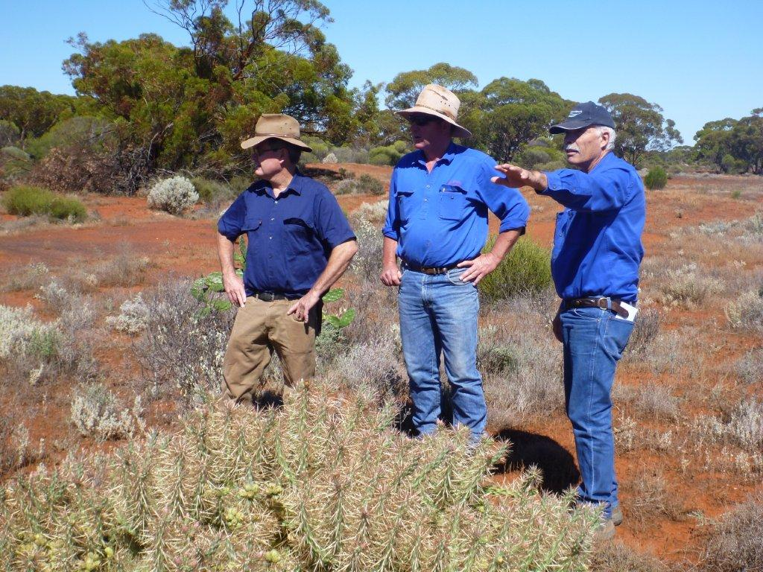

prepared by

ROSS WOOD

Table of Contents

INTRODUCTION 4

GNRBA inc Aims and Objectives 6

Activities and achievements 2015 – 2016 6

Governance and projects 7

2015/16 Grants and Projects 7

Grant projects in application phase for 2015/16 8

Wild Dog Control 9

Baiting operations 9

aerial baiting 9

Large Feral Herbivore Control 10

Mining company support 10

Wild dog activity and reported stock losses 10

NON TARGET DEATHS 11

WEED CONTROL 11

FINANCES 11

CONCLUSION 12

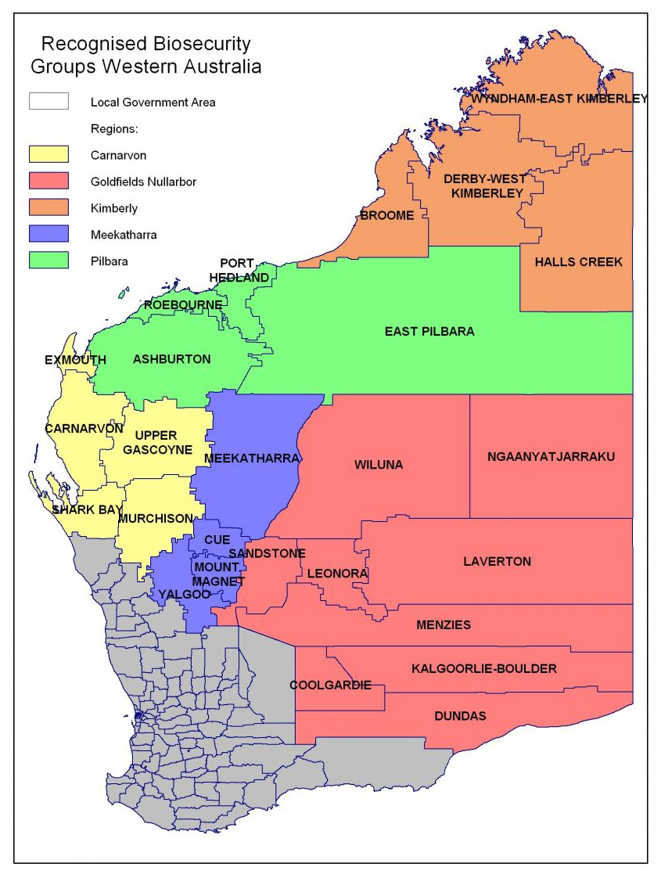

GNRBA operational area

# INTRODUCTION

**The Goldfields Nullarbor Rangelands Biosecurity Association** **Inc.** (GNRBA) is unique in rangeland management across Western Australia. It has a huge area to service and is working hard to provide a top class service to ratepayers. It is now well recognised as being a leader in the RBG’s in WA.

The GNRBA Inc formally became operational on 1st July 2011. At this time it took over the APB Zone 9 operations.

**GNRBA Management Committee**

The GNRBA is managed day to day by Ross M Wood as Chief Executive Officer. Committee of Management (CoM) Meetings are held face to face or phone hook- up as required.

The Management committee for 2015/16 was comprised thus:

**Trevor Hodshon** 2 year Term **Chairman**

**John Oxley** 2 year term

**Ian Kealley** 2 year Term **Associate Member DPaW**

**Julian Jones** 1 year Term

**Justin Stevens** 1 year Term **Hon. Treasurer/Secretary**

**Brett Day** 1 year Term

**Ross Wood** 3 year Term **Chief Executive Officer**

**Brendan Jones** 3 year Term

**Doug Brownlie** 3 year Term **Vice Chairman**

Trevor Hodshon was elected as Chairman of GNRBA Inc by Committee of Management for 2015/16.

The GNRBA Inc. is the formally recognised Biosecurity Group and has the ability to request the Minister of Agriculture and Food to determine a declared pest rate (Under section 130 of the BAM Act) on pastoral leases in its area of operation. This rate is matched by State Government funds. This allows the GNRBA to effectively double pastoralist’s funding to assist with the control of declared pests.

Importantly the GNRBA partners with Shires and others like Rangelands NRM WA, to leverage funds and further increase its ability to provide services.

The GNRBA Inc. role is to assist and compliment pastoralists’ efforts to control pests and weeds. It is not there to replace pastoralists control efforts and activities.

The Department of Parks and Wildlife (DPaW,formally DEC) is an Associate Member of the Group. It is the responsible state agency for managing wild dogs and pests on Unallocated Crown Land (UCL) and national parks estate. To achieve this DPaW employs a dogging contractor to undertake wild dog control in the region and also assists in funding aerial baiting programs in the region.

To compliment DPaWs work, the GNRBA Inc allocates funds for two part time doggers (LPMT’s) to carry out wild dog control on private properties. However, the majority of wild dog control work by GNRBA is required on UCL with the DPaW dogger working in coordinated effort. Department of Parks and Wildlife has also contracted to GNRBA to undertake some wild dog control programs on the Nullarbor region.

During the 2015/16 financial year, approx $66,000 funding through the Royalties for Regions (R4R) program was again available to the group. The GNRBA Inc secured a supply contract for the Group to be able to access these funds. This funding has been used to support aerial work hitherto not funded. This funding has now been renewed for another year subject to the WA Wild Dog Action Plan implementation program.

R4R funding is an important external funding source and is very much appreciated. It is largely targeted for UCL alongside small stock properties and has helped to broaden aerial baiting areas in the Nullarbor and in Kalgoorlie and Sandstone areas.

This document reports on the GNRBA Inc. activities and will not detail the extent of Department of Parks and Wildlife wild dog control activities.

Other Associate members of GNRBA are the shires of Dundas, Leonara, Wiluna, Menzies and Laverton. It is hoped that the other Shires in the area can be encouraged to participate more fully.

GNRBA is encouraging such participation through engagement with the Goldfields Voluntary Organisation of Councils (GVROC) and individual shires.

The GNRBA Executive Officer has been actively working with Menzies, Leonora, Coolgardie, Dundas, Laverton, City of Kalgoorlie/Boulder and Wiluna Shires particularly in relation to invasive Cactus control.

In particular the GNRBA actively managed the Menzies and Mertondale projects which were funded by GNRBA, Menzies and Leonora Shires and Rangelands NRM WA. This project has been successfully implemented and completed.

Importantly the GNRBA engaged with Windidda, Pinjin and Adelong Stations to develop a more integrated pest program this year. The GNRBA has also established a good working relationship with Aboriginal native title holders including Spinifex, Birrliburu and Ngadju.

The GNRBA also works with and supports Kalgoorlie Boulder Urban Landcare Group (KBULG) to encourage cactus eradication in City Kalgoorlie/Boulder. These relationships are assisting GNRBA achieve more credibility and recognition.

A recent example of this collaboration was the engagement of the KBULG CEO to manage the Williamstown cactus clean up project. KBULG arranged a fantastic partnership with City CKB, KCGM, DAFWA and importantly Boulder Contracting and Maintenance to physically remove some 765 tons of Cactus and rubbish for deep burial.

This effort has been recognised at the highest levels including a thank you letter from the Governor of WA to KBULG CEO.

A continuing partnership with Rangelands NRM WA to secure funding has been an important addition to the GNRBA influence in the region.

The GNRBA works closely with and alongside the DAFWA Invasive Species Program team and acknowledges the considerable help and advice provided by Mac Jensen and Jim Miller in all facets of our operation. This has been of great mutual benefit to both organisations.

Regrettably, Mac Jensen is about to depart DAFWA after our scheduled GNRBA/Wiluna LFH shoot to join the DPaW team. This relationship will be maintained and I am sure that the GNRBA will be able to work with Mac constructively in his new role. He has been a fantastic supporter of the GNRBA and GNRBA acknowledges his efforts.

## GNRBA inc Aims and Objectives

* Initiate, promote and foster the control of declared animal and plant pests
* Encourage all persons to adopt sound biosecurity practices
* Prevent land and biodiversity degradation to protect our resources
* Foster sustainable development & production
* Act as the “Voice” for landholders (pastoralists and others) in the region

## Activities and achievements 2015 – 2016

GNRBA Inc purchased about 70,000kg fresh meat baits from a number of suppliers at a cost of $330,000.This was delivered to our Kalgoorlie freezer and direct to properties. The GNRBA funded four ground baiting’s and several aerial baiting programs. A further aerial baiting was organised for eastern Nullarbor on Unallocated Crown Land using R4R funding.

Importantly the GNRBA recognises the difficulties around making baits for pastoralists and has this year obtained the services of Teen Ryan, Andrew Parker and Brett Day to produce baits for distribution. Ryan alone injected some 270,000 baits at Credo.

Good financial accountability systems continue to be implemented. Mike Hutson is our accountant based in Kalgoorlie and is overseeing the Association finances which are now complicated with so many grant funding sources.

K Mader and T Ryan are the Association’s LPMT’s (doggers) operating in the Sandstone, Kalgoorlie, Laverton and Nullarbor areas primarily.

This year the Group continued to upgrade its S7 facilities. Teen Ryan is the group’s S7 distributor. The GNRBA is now independent from DAFWA in this area.

Last year the GNRBA also undertook to train LPMT Teen Ryan in weed control. This better utilizes her abilities whilst travelling around properties. She can now spray weeds and cactus at remote sites such as Forrest.

The GNRBA also been partnering with the Shires where possible to achieve cactus, large feral herbivore and wild dog control.

This year the GNRBA EO undertook several trips with DAFWA support to other RBG’s and also to Tjuntjunjarra to better understand the complexities of Native Title and to engage with Spinifex traditional owners on issues such as camel control, weeds and baiting. Previously we have engaged with Birriliburru and encouraged cactus control projects at Wiluna.

## Governance and projects

The GNRBA as an incorporated body follows the Rules of Association. The Goldfields Nullarbor Rangelands Biosecurity Association Inc GNRBA) trading as the GNRBA operates using the declared pest rate, matching Government funds and allocated R4R funds.

It also attracts and acquits special purpose grants such as the Rangelands NRM WA “Corralling the Cactus” project.

### 2015/16 Grants and Projects

* **Menzies/ Mertondale** A $40,000 State NRM grant matched by Shires of Menzies and Leonora to map and spray Hudson Pear cactus at Menzies Tip and Coral cactus at Mertondale. This project managed by GNRBA is complete, audited and signed off. The GNRBA continues to work with Menzies Shire which provided a further $20,000 for the Group to continue work at Menzies Tip and Kookynie. The Leonora Shire continues to work with GNRBA to deal with cactus in the area.
* **Tarmoola** This $100,000 original Rangelands NRM WA grant has been acquitted and report submitted. More work on this site is yet to be done. However the immediate threat is diminished. We are now working towards releasing a cochineal bug to assist Tarmoola and indeed the Leonora area deal with Coral cactus. Cochineal bug was imported from Qld and we have been rearing.
* **Wild Dog Remote Sensing Trial** A $20,000 Rangelands NRM WA grant to map probable wild dog habitats for each station based on landforms such as breakaways is complete and maps available to stations to plan baiting around natural formations such as breakaways. This project has been acquitted.
* **R4R Research Cacti Grant** This is a $158,000 R4R grant over 3 years to establish potential to utilize drones to identify and map known cacti infestations to assist control. This work has just commenced and most ground work is complete. UWA scientist are now processing and analysing the data.
* **Railroading the Cactus** This $30,000 State NRM grant is to start dealing with Legacy Cactus from Transline settlements. This work commenced in Sept 2015 and is now complete. Follow up work will be done as required.
* **Balladonia Telegraph Station clean up.** The GNRBA undertook to eradicate this infestation in a timelymanner to prevent a greater problem.
* **DAFWA Capability Grant** A $130,000 grant to amongst other things;

Launch our GNRBA website and email capacity, upgrade our filing systems, purchase a bait trailer, organise an automated aerial flight plan, spray African boxthorn at Eucla and several field trips is underway.

* **DAFWA Grant** A $30,000 grant for assisting EO upgrade aerial baiting and RCP processes.
* **Rangelands NRM WA and GEDC Grant** $15,000 eachto run this AGM/Innovation Conference on the strength of last year’s event.
* **Governance training.** This year State NRM grant allowed the Committee of Management to participate in a workshop called The Board and the CEO. This was well attended and very useful to our board.

### Grant projects in application phase for 2015/16

* **DPaW Tender for Wild Dog control work in Goldfields and Nullarbor.**

This project was successfully tendered for, accepted and subsequently withdrawn on technicalities. It is currently being reviewed. It is an important tender for GNRBA as it will better allow for more coordinated dog control. The GNRBA is hopeful that a resolution is forthcoming. This is out of our control but necessary steps have been taken.

* **Bromus Burr Buster**  Fencing for Noogoora burr at Bromus Dam near Norseman**.** Dundas Shire assisted Ngadjurangers put up fence. This is being monitored by rangers and GNRBA is supporting their inspection andcontrol endeavours.
* **Signage to Save dogs** Signage for 1080 for all GNRBA Shires (work in progress)
* **1080 warnings are now in Hema maps** ( This program will expand)
* **Secure bait making facility racks.** To allow more efficient preparation of baits close to Kalgoorlie to assist pastoralists struggling with bait preparation.(work in progress)

In addition to above the GNRBA is engaging GWW and Ngadju rangers based at Norseman. Initially we have worked with them at Bromus Dam and at Rawlinna “Railroading the Cactus” spraying cactus.

## Wild Dog Control

### Baiting operations

Aerial baiting was conducted within the GNRBA area of operations this financial year and wide spread ground baiting was carried out by pastoralists, DPaW, and GNRBA LMPT contractors.

The GNRBA purchased two large chest freezer units for use by Teen Ryan to produce an economical supply of fresh meat baits for use on UCL. Procured fresh meat baits are stored in the freezers. The GNRBA also uses a freezer based at Weebo station to assist with the baiting programs.

The GNRBA has purchased some shelf ready 1080 baits to use this summer where bungarra activity seems to diminish the effectiveness of fresh meat baiting.

DAFWA is coordinating online training program to allow all pastoralists to be able to lay 1080 baits. This will allow more flexibility but Pastoralists should ensure good 1080 protocols are maintained. A training course was conducted last year by an approved contractor in Kalgoorlie and paid for by the GNRBA. It is anticipated that this program will become an annual event.

The GNRBA is concerned that any failure to adhere to protocols may lead to the loss of 1080 as a management tool. As such the GNRBA is maintaining a public awareness campaign through the media and public notices and encourages pastoralists to be vigilant toward advising neighbours of baiting activities and following the rules when using 1080, including appropriate signage.

### aerial baiting

The GNRBA coordinated aerial baiting’s in December 2015 in Nullarbor, Kalgoorlie and Northern Goldfields and June 2016 in the Eastern Nullarbor, Laverton, Wiluna, Leonora and Sandstone areas.

The December baiting was combined with ground baiting and the June baiting was paid for by GNRBA and R4R.

A GNRBA funded aerial baiting for November 2016 has been budgeted for and will be coordinated by GNRBA.

If suitable contractors can be sourced and baits can be delivered cost effectively then aerial baiting is an important tool that can be used to target areas that are inaccessible to ground based staff. In conjunction with DPaW the GNRBA will continue to plan and budget for aerial baiting operations throughout the affected landscape.

### Large Feral Herbivore Control

The GNRBA conducted successful and cost effective aerial Large Herbivore shoot jointly funded and in partnership with the Wiluna Shire and GNRBA using the DAFWA Shoot team.

1,246 LFH Oct 2014 31 LFH/hr @$37/animal

1,858 LFH April 2015 37 LFH/hr @$36/animal

1,162 LFH October 2015 25LFH/hr @$54/animal

In Nov 2012 The Australian Feral Camel Project also shot 1,591 LFH in this area

Total LFH culled in this area in 3 years has been 5,857. An estimated 1,200 LFH were shot by pastoralists during this period. At the time of writing this report planning was well underway for the aerial shoot in October 2016.

An ammunition allowance of up to $500/per property for those properties on UCL interface facing extreme hardship from Large Feral Herbivores is available by discussing with Executive Officer.

Mining company support

It is hoped that GNRBA Inc will garner support from Mining companies in the area. Their involvement will greatly assist the GNRBA provide a more comprehensive service. Wild dog, weed control and quarantine issues for earthmoving plant are issues the GNRBA Inc. considers very important.

In 2014 the EO addressed the Laverton Mining Liaison meeting at Laverton Shire. This was a good forum to get our messages across. It is hoped another opportunity will be made available in this financial year.

## Wild dog activity and reported stock losses

Wild dogs continued to impact on pastoral activities across the Goldfields Nullarbor region during 2015/2016. During this period reported stock deaths from Wild dog attacks have continued to affect confidence in the GNRBA efforts and pastoralist enterprises.

Reported wild dog activity in 2015/16 occurred across the entire GNRBA area.

Except for the Nullarbor, Edjudina, Kalgoorlie and Sandstone area small stock activity has ceased largely as a result of an inability to consistently control wild dogs.

### NON TARGET DEATHS

Several non-target species deaths have been reported this year. These are investigated by DAFWA to ensure protocols have been adhered to. It is essential that 1080 is used carefully. These investigations are a waste of limited resources and the GNRBA wishes to ensure that 1080 Signage is obvious. It is a requirement that all public entrances to properties must be adequately signed. The GNRBA have had stencils made up to assist in the process.

## WEED CONTROL

The GNRBA is developing a weed management plan covering the group’s operational area. The plan is essential when applying for funding and assistance.

To this end we have had Bathurst Burr meetings in Kalgoorlie and at Rawlinna. It is anticipated that when complete it will give pastoralists guidance on how to deal with weed issues and compliance.

The GNRBA has continued to manage many cactus projects in the region and brought on board many partners in the process. This has assisted us to build credibility in the community.

GNRBA continues to assist with chemical and equipment to support eliminating a long standing Parkinsonia infestation on Granite Peak Station.

This year we continued to collaborate with GWW and Ngadju Rangers at Norseman to assist in eliminating a Noogoora Burr outbreak at Bromus Dam. GNRBA has assisted with quality signage. We have also engaged the Rangers to assist with the “Railroading the Cactus” project on Transline. This was a great success at Rawlinna.

The GNRBA manages a weed chemical subsidy process that reimburses pastoralists up to $500/property for dealing with declared weeds such as Bathurst Burr. To apply for this assistance please contact Chief Executive Officer.

## FINANCES

The GNRBAhas managed funding and expenditure of $1,036,000 this financial year using its traditional rate base and matched funding to leverage R4R funding, grants and Shire contributions.

These arrangements are managed day to day by the Executive Officer, overseen by the Treasurer. The GNRBA uses accountant Mike Hutson as management accounting and Pat Leighton FCA for Audits.

The 2015/2016 Financial statements have been Audited and found to be correct and in order.

The GNRBA continues to advocate for a Biosecurity Levy on all Shire rates to better fund its work into the future. This way Pastoralists are not the only ones paying for everyone’s usage of the rangelands. Grants have been a tool for assisting the GNRBA to achieve credibility and runs on the board.

## CONCLUSION

The 2015 -2016 year has seen the group continue to complete its financial and operational independence process and has positioned itself to secure additional funding through the R4R project, Rangelands NRM WA and other Federal Government Grants.

The Association has contracted a private consultant Erin Gorter to assist the ECO as a project’s officer. Erin is well connected and a great help to CEO in management of projects.

The GNRBA Committee of Management is adopting a more proactive approach to securing funding to assist pastoralists and land managers in the region.

There are still processes regarding provision of Operational Plans that the GNRBA has to comply with to access the matched government funding.

Wild Dog activity over the area continues to have a serious impact and more resources need to be made available to help bring the impacts of wild dogs under control in the Associations’ area of operation.

The Association’s Committee of Management is mindful that it does not become complacent and that the level of involvement from all parties is maintained across the whole landscape.

Resource levels need to be increased; relationships built on and clear management and business plans developed.

The GNRBA continues to deliver quality results to the livestock industry within the Goldfields Nullarbor. These include;

* Continual development of a 3 year management plan.
* Encouragement of members to participate on Management committee and to use their abilities to build the GNRBA’s effectiveness.

The GNRBA takes this opportunity to thank outgoing Regional manager of DPaW Ian Kealley for his work on the CoM. It is expected that his successor will take an active role in this partnership.

Likewise Doug Brownlie has left the region and the CoM thanks him for his participation.

The GNRBA Inc. has had a positive effect upon wild dog predation during the 2015-2016 financial year. The GNRBA Inc has worked hard to reduce the impact of wild dogs, camels and weeds on pastoral enterprises; it has secured substantial funding until 2017.

Increasingly the GNRBA needs to find ways to address the issue of large herbivores (camels and horses). It has been endeavouring to affect control programs on the interface between UCL and pastoral properties by working together with the Wiluna Shire and pastoralists.

The GNRBA continues to expand its operations into the control of invasive cactus in GNRBA area and has applied for several grants to assist in this work.

Ross Wood

CEO GNRBA Inc.

6th Oct 2016