**Farmer wants a life – sheep research open day**

**Connecting the dots – the value of an agri-internet of things**

Darren Gibbons, Department of Primary Industries and Regional Development

## Abstract

As Internet of Things (IoT) continues to gain acceptance, the number of sensors continue to grow exponentially. Some analysts, such as Statista, forecast that the number of installed IoT devices will be in excess of 70 billion by 2025.

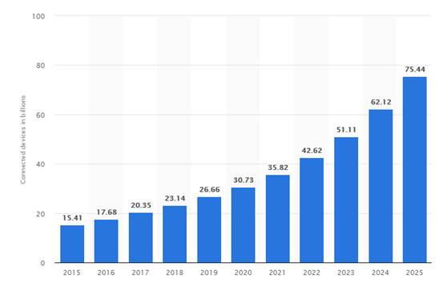

Figure Chart depicting connected devices in billions plotted against years

If these forecast estimates are to be believed, the traffic generated across the internet by these sensors is going to cause some scalability issues to handle the sheer volume of data. Furthermore, the ability to analyse this data and derive real value will be a key challenge and the focus will be on determining where should small versus big data analysis be undertaken.

KPMG, in their 2016 report on infrastructure for smart farming, have forecast that by 2025, 70 per cent of enterprises will have embraced IoT and smart farming technology in their business operations. It is assumed that large farming operations will lead the uptake of this new technology, with smaller businesses taking the opportunity to invest in second hand equipment some five years after early adopters. KPMG, in their report, ascertain that the lack of continuous and reliable connectivity is restricting the adoption of technology, especially for machine devices. A desktop review identified that competitive nations are more advanced in providing connectivity in agricultural areas and adopting smart farming.

The eConnected Grainbelt project is actively looking to help identify the value and future growth of IoT data and is currently working with the Katanning Research Facility to improve connectivity to the facility as well as help provide a whole-of-farm digital reference site using long range sensors and other WiFi technology.