SIBI new on-farm technology economic case study: pedigree matchmaker

# Case study: Pengilly family of Cascades

**Owners:** Bruce, Trudy and Thomas Pengilly  
**Property location:** Cascades, 102km North West of Esperance  
**Property size:** 4000 hectares   
**Stock:** 1800 poll merino ewes, 350 stud ewes artificially inseminated  
**Technology:** Pedigree MatchMaker

Thomas, Bruce and Trudy Pengilly farm 4000 hectares at Cascades near Esperance. They run a mixed farming operation with 60% of the farm cropped and the balance carrying a 1600 ewe poll merino flock including a 500 ewe stud.

Around 350 of the stud ewes are artificially inseminated each year and Australian Sheep Breeding Values (ASBV’s) are used with the breeding program. With the sire known, having the ewe pedigree improves the breeding efficiency and Thomas believes the rate of genetic gain is around 3% faster knowing the ewe ASBV.

There are several options for determining the ewe pedigree:

* genetic testing using DNA analysis
* visual identification of mother and lamb
* electronic proximity analysis using Electronic Identification (EID) eartags, such as Pedigree Matchmaker.

## Genetic testing

Genetic testing is the gold standard, providing the highest level confidence in the lamb’s lineage with over 95% of lambs determined but at this stage is still too expensive to be widely adopted costing $17.00 per lamb plus the cost of the ram or ewe if it hasn’t already been done.

## Visual identification

To identify the ewe for each lamb can be done at birth or prior to weaning but involves some separation from the mother and may result in some deaths if done at birth. While not quite as good as genetic testing, it provides greater than 90% maternal accuracy at a lower cost.

The Pengilly’s breeding program doesn’t require birth weights, so they sample later. It was Trudy’s job each year to do this “We run four paternal lines of approximately 100 ewes each within the stud and we’d bring them in separately. I’d send Thomas out to muster the sheep which took about an hour, then we’d draft out the lambs from the ewes before coming in for coffee. After half an hour or so we’d go back and start placing the lambs in with the ewes to see who they were mothering with and once we identified the ewe we’d start again with the next one.”

The whole process took around five hours with one person flat out and the other working about half the time. At the end of the day the flock would be released back to the paddock and even though the farm has laneways they would still need to be pushed back to the paddock taking around an hour and a half.

To run each group of around 100 ewes with their lambs through took all day with eleven and half hours of labour or around seven minutes per lamb. On the farm it was hard work and after four days on the AI stud, repeating the process with the hoggets wasn’t generally done. While it was a lot of work, it’s still a lot cheaper than genetic testing, costing around $5.50 per lamb in labour costs.

Identifying lambs at birth is another option, taking around two hours per day through the six week lambing program where the flock is examined each day, but the costs are slightly higher taking around 10 minutes per lamb compared to seven minutes for yarding, the equivalent of an extra $2 per lamb. In a stud environment where lamb birthweights are being taken this investment may be justified as the best option.

## Pedigree matchmaker

EID technology provides another option for determining parentage by using the mothering instinct to link lamb to ewe. Lambs walk with their mothers so by identifying the lambs with the highest proximity to ewes we can determine the ewe pedigree with a high degree of confidence.

Pedigree matchmaker works through placing an EID tag on each ewe and lamb. A panel reader is then placed into a constriction point the animals need to walk past regularly and slowly closed down to about 80cm to enable the reader to recognise each animal as it walks past. After two weeks the maternal lineage can be calculated with the same level of confidence as physically identifying the sheep. The four mobs with separate paternal lines that were previously run separately were run as one mob through the pedigree matchmaker.

Setting up the reading panel is important as you need to give the sheep a reason to walk past the reader such as having feed on one side and water on the other. According to Thomas “it took us a while to work out the panel reader placement and we probably took two years before we got it right.” The best system needs to force the animals past the reader and requires a bit of sheep psychology to get it right. The simplest way is to separate either feed or a lick attractant from the water source with the Pedigree matchmaker located in between so the sheep have a reason to go past it regularly (Figure 1).

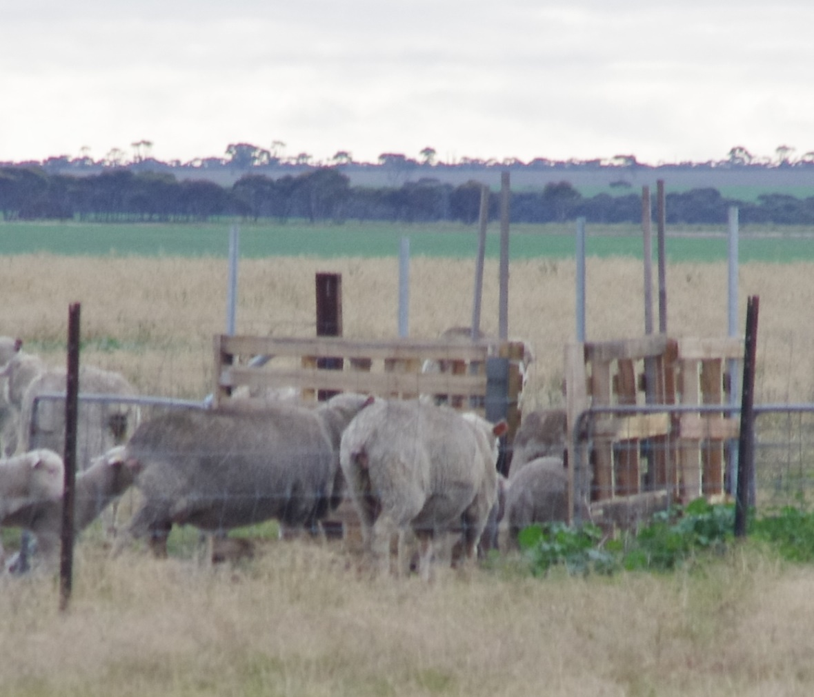

Figure 1 Ewes and lambs walking through the Pedigree Matchmaker

## Results

Historically the Pengillys had run the four paternal lines through the yards taking around 41 hours with a value of $1860 in labour. The labour cost has been priced for a farm manager earning $87 000 per year or total costs of $46/hour including superannuation. While the hoggets generally weren’t done, including them would have increased the time to 64 hours or $2930 each year. Timing was difficult occurring just after seeding when labour was at a premium so matching the hoggets was not a priority due to the difficulty of working with the hogget ewes and the time of year, immediately after seeding when demand for labour on farm was high.

The Pedigree matchmaker system cost $3345 to purchase. Each year the system needs to be setup for each mob taking around an hour over a week to slowly close the gate down to the 80 centimetre (cm) width required. In the first couple of years, there is some skill involved in setting up the system, so it’s assumed the system only operates at 50% efficiency. Pedigree matchmaker requires EID ear tags costing around $0.50 more than normal ear tags to use but the Pengillys don’t value this as the EID ear tags are used elsewhere within their system and are purchased anyway. To analyse the data at the end of the year, costs $100. The total cost for setting up, taking down and running the system each year is $284 across the four paternal lines that were previously run as four mobs. It takes a while to get the sheep walking correctly past the panel, with only 50% of the maternal parentage determined in the first two years.

With the system expected to last 10 years, pedigree matchmaker has a net present value (NPV) of $8,309 and a benefit cost ratio of 3.2. For each dollar invested, the system returns around $3.20 over its life. The payback period is three years. Increasing the discount rate reduced the value of the system in later years, but still made it profitable (Table 1).

Table 1 Increasing the discount rate reduced the value of the Pedigree Matchmaker

| Discount rate | 5% | 6% | 7% | 8% | 9% |
| --- | --- | --- | --- | --- | --- |
| Net present value | $9000 | $8300 | $7600 | $7000 | $6500 |
| Benefit cost ratio | 3.3 | 3.2 | 3.1 | 3.0 | 2.9 |
| Payback period | 3 years | 3 years | 3 years | 3 years | 3 years |

Including the hoggets in the analysis increases the efficiency of the system with only limited extra costs. The net present value increases to $12 000 and the benefit cost ratio to 4.2. The system is highly dependent on the number of lambs being matched and the table below shows the results for varying flock sizes at a discount rate of 6% (Table 2).

Table 2 Influence of number of lambs matched on the net present value of Pedigree Matchmaker

| Lambs matched | 100 | 117 | 150 | 200 | 250 | 350 | 550 |
| --- | --- | --- | --- | --- | --- | --- | --- |
| Net present value | -$600 | $0 | $1200 | $2900 | $4700 | $8300 | $15100 |
| Benefit cost ratio | 0.9 | 1.0 | 1.4 | 1.8 | 2.3 | 3.2 | 4.6 |
| Payback period | 10 years | 3 years | 6 years | 5 years | 4 years | 3 years | 3 years |

The ewe hoggets should be the best genetic animals in the stud, so understanding the Australian Sheep Breeding Values (ASBVs) of their offspring should increase the value of the investment even further. The extra value of including the hoggets hasn’t been included in the analysis, just the time savings.

Including the value of the EID tags didn’t make a material change in the return, dropping the NPV from $8300 to $7100 and the BCR from 3.2 to 2.4 times.

Because Pedigree Matchmaker is a labour saving device, the cost of labour is a key driver in determining profitability. In the Chris Patmore system of using remote cameras to monitor water, if they are using labour at $55,000 per year the NPV drops from $8300 with a BCR of 3.2, to $3800 and a BCR of 2.1. Similarly if all the work was done by the owner, say in a single person farm, then the cost of labour increases to $120 000, then the NPV increases to $12 800 with a BCR of 4.2 times.

Leasing the Pedigree Matchmaker is another option, where it can be leased for three to four weeks before returning to the manufacturer. The lease costs are around $110/week and it will need to be posted and returned as well. Comparing leasing the system to buying, leasing comes out slightly worse than buying with a NPV of $7500 and BCR of 2.7 against buying at $8300 and 3.2 times. While leasing costs a little more, the technology is constantly being updated so you don’t have to worry about the system getting older and it is worth considering. Thomas gives a word of warning about leasing though “It took us a while to get the system working and if we’d been leasing, I’m not sure we would have kept going. Now we’ve got it working Pedigree Matchmaker is great, but it took a while to get to where we are now.”

## Conclusion

Pedigree Matchmaker is a labour saving investment with significant time savings available for farmers. With 350 lambs being pedigreed each year, there are significant savings with a benefit cost ratio of 3.2 times, and a net present value of $8300.

The key factors driving profitability of an investment in Pedigree matchmaker are the number of lambs marked and the labour cost saved.