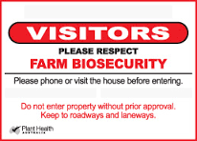
Business name …………………………………………………………………..

Contact …………………………………………………………………..

Office …………………………………………………………………..

Mobile …………………………………………………………………..

Email …………………………………………………………………..

Completed by ……………………………………………………………….....

Signed …………………………….. Date ……/……/……


This template is funded by Horticulture Innovation Australia using the National Vegetable Levy
and funds from the Australian Government.

 Template originally created by NT Farmers
Farm map - please show:
- Growing area and restricted zones
- Wash down point for entry to the clean farm, location of footbath
- Access for visitors, deliveries, pick ups
- Any domestic areas - sheds and dwellings
- Roads, gates and fences
Farm Map

Major Risks | Actions | In place/completed |  |  | Comment
Major Risks | Actions |  | X | N/A | Comment
Signs and gates  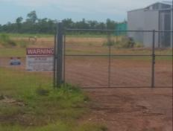 | Biosecurity signs in place at property entrance  Manage access to your property through a single access point- other access to shut and lock  Phone number on the biosecurity sign  Parking area signs in place
Seeds and seedlings  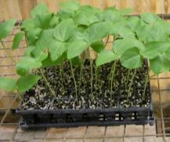 | Certified CGMMV clean seed or own “clean and tested ” seeds should be used  Seedlings from registered nursery in new trays. Avoid using recycled trays  Seed and seedling register completed
Major Risks | Actions | In place/completed |  |  | Comment
Major Risks | Actions |  | X | N/A | Comment
Staff  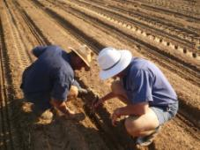 | Staff trained in biosecurity and record completed  Clothes and equipment cleaned daily or on re-entry. Boots and secateurs used only on farm and cleaned between tunnel/planting blocks (e.g. 1% chlorine or 1% Virkon S)  Footbath available (recipe is on the back of this page)
Visitors  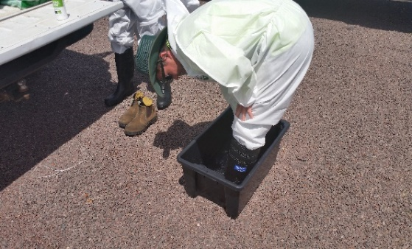 | Visitors, contractors and staff to park in designated area  Restrict movement of vehicles on-farm  Contact farmer before coming on-farm  Register all visitors and contractors to the site
Major Risks | Actions | In place/completed |  |  | Comment
Major Risks | Actions |  | X | N/A | Comment
Visitors and contractors informed of your farms biosecurity measures

All visitors to use a footbath before entering the production area

Visitors don’t bring plant material on farm

Machinery/vehicles  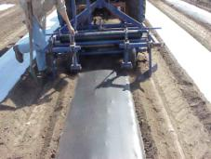 | Use a concrete wash down area located near to the front of property with run-off collected to not contaminate growing area  Clean any machinery or vehicles coming onto the growing area or leaving the farm with a high pressure cleaner with detergent  Wash down water to be collected in confined area (sump, evaporation pond)  Complete register of machinery coming onto the farm
Major Risks | Actions | In place/completed |  |  | Comment
Major Risks | Actions |  | X | N/A | Comment
 | Use on-farm only vehicles if possible for transport around the growing area
Deliveries and pick ups  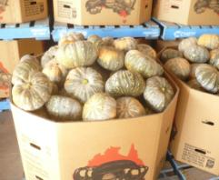 | All deliveries and produce pickups are done at a designated area  Field crates and bins washed and disinfected when moving from one production area to another  Wooden pallets are cleaned in a 1% Chlorine bath before going into the farm area and placed on a stand or hard surface area. Avoid used or recycled packaging  Hardstand loading area to be cleaned once produce has been picked up
Major Risks | Actions | In place/completed |  |  | Comment
Major Risks | Actions |  | X | N/A | Comment
Weeds  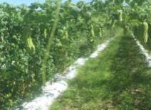 | Know and identify the host weeds for CGMMV on your farms  Remove host weeds where possible  Monitor for volunteer host plants  Monitor wash down surrounds for host weeds or plants and remove them
Animals and Birds  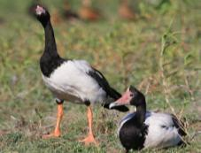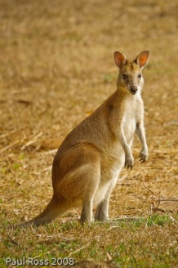 | Fences and nets maintained to restrict access to production area  Reduce food sources by managing waste produce  Dump waste away from the growing area in a designated area  Deep burial is required for disease neutralisation in waste material
Major Risks | Actions | In place/completed |  |  | Comment
Major Risks | Actions |  | X | N/A | Comment
Pests and Disease  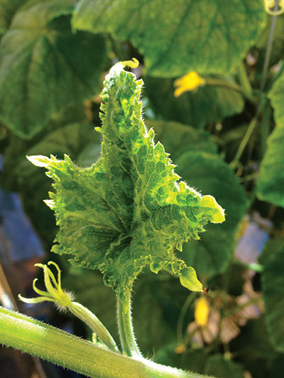  Lebanese cucumber leaf with CGMMV | Know and monitor for pests which can spread the disease  Monitor crops regularly for disease symptoms  Train workers to identify and report the symptoms of CGMMV
Waste  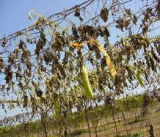 | Old crops are sprayed out (e.g. glyphosphate or glufosinate) and removed - not rotary hoed into the ground  Waste produce is burnt and placed under deep burial away from growing area
Major Risks | Actions | In place/completed |  |  | Comment
Major Risks | Actions |  | X | N/A | Comment
Response to Infection  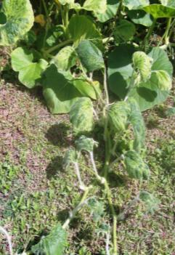 | Isolate the infected crop area and restrict movement to the area  Where required infected area should be entered as the final activity of the day  Get all production areas tested for CGMMV and inform staff  Test the soil before replanting  Field crops  Spray out and remove infected dead crop material  Plant a non-host cover crop  Monitor other host crops closely
Major Risks | Actions | In place/completed |  |  | Comment
Major Risks | Actions |  | X | N/A | Comment
Greenhouse
Remove (bag, burn or bury) infected and nearby plants, avoiding contact with other plants

Disinfect all surfaces


1% Chlorine Solution using domestic bleach products (42g/L active chlorine)

250ml of bleach per I Litre of water
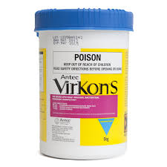
1% Virkon S Solution

2 scoops in 10 litres of water
How to clean/disinfect
Have a dedicated area for cleaning
Physically clean off organic matter with high pressure water or compressed air.
Use 1% Chlorine Solution (1-10 minute) rinse in water
Hands – wash with soap 1 minute

Registers
Seed and seedling register

Crop | Variety | Seed company | Batch number | Certified CGMMV tested |  | Date purchased | Date planted
 |  |  |  |  | X | Date purchased | Date planted

Machinery movement register

Date and Time | Machinery/  vehicle | Identification | From where | Intended use | Checked by | Signature

Visitors register

Date | Name | Company | Reason for visit | Time in | Time out | Induction
 |  |  |  |  |  |  | X

CGMMV monitoring record

Date | Crop and location | Inspected by | Unknown or suspect detection of CGMMV | Number of plants affected | Action taken

Staff training record

Date | Employee / worker | Farm Biosecurity training |  | Trainer | Comments
Date | Employee / worker |  | X | Trainer | Comments

